

... men fainting with fear and with foreboding of j what is coming on the world . . .
Luke 21, verse 26

THE WORLD LOOKS GOOD
from a thousand miles in space. :
But thinking people know that • ,
all is far from well.
Many see no way out. o
Given time man might survive-
but time is running out.
EVERY YEAR OUR CROWDED WORLD
gets more crowded. Those already hungry
get more hungry,
while many die hungry.
What food there is to share...is not shared
for the rich eat
and many poor do not.
FOOD SUPPLIES MAY INCREASE
slowly, but not quickly enough to solve the problem. * —More and more land
is used for other purposes.
* —Pollution spreads over the world
like a disease,
doing untold harm to fertile areas. Serious people worry about its long term effects.
: * —Meanwhile, as food is failing
other vital resources
are known to be running out.
WHILE SCIENTISTS WORK
in hope of better days
*—Strain and stress increase
; for many ordinary people
•*• —How long will it be
before someone under strain '
> explodes a nuclear bomb?
THE GOD CHRISTIANS WORSHIP .has a way out of this mess.
/ will restore the fortunes of my people ISRAEL
and Judah, says the Lord, and I will bring them
back to the land . . . Jeremiah 30, verse 3


PERHAPS THE WORLD SEEMS TO YOU
to be out of control. It may look as if it's rushing headlong to destruction.
But man will not be allowed to destroy the world. The Christian knows
that God is in control.
ALL THROUGH HISTORY
He has guided the affairs of men.
He cares about what's going on,
and directs operations .::'
as part of His long term plan.
God knows what He is doing.
ONCE GOD CHOSE A NATION
as His own people. It was a political kingdom, with laws, a land,
and leaders.
; God was in control
and He guided Israel in all their ways.
HE SAVED THEM FROM THEIR ENEMIES
sent them guidance and help,
sent His Son to save them.
Even when He punished them
by scattering Jews all over the world
" and making their land barren,
•^ He never lost interest.
••£•'
WHEN GOD ACTS
to help a sorry Israel out of trouble, He will go on
to solve all world problems.
GOD HAS STARTED TO HELP ALREADY
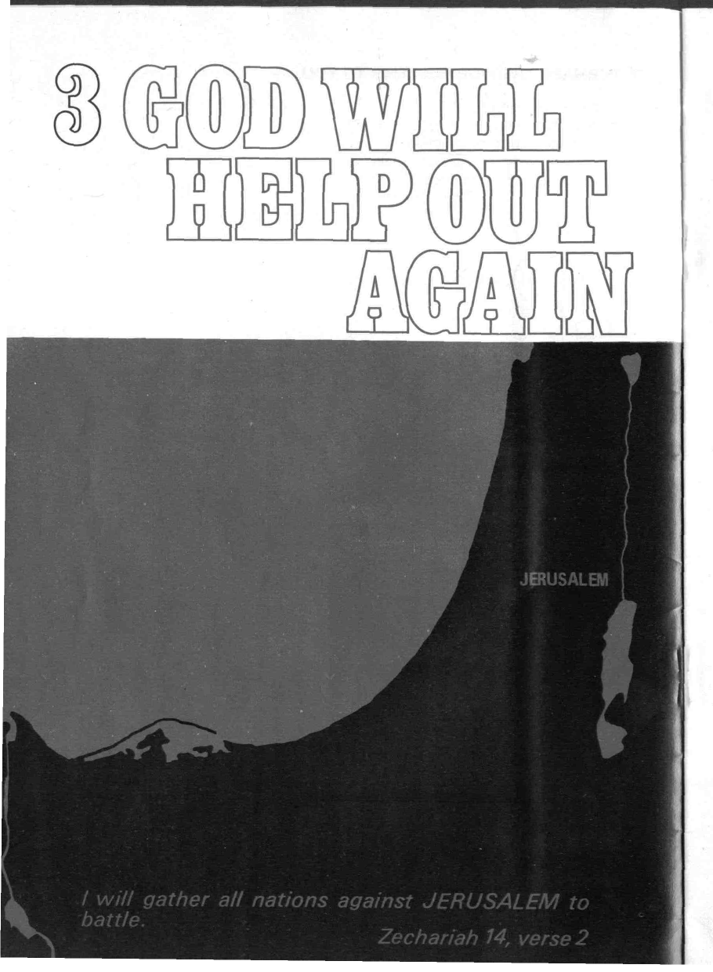
The people He scattered
for their persistent disobedience are now being regathered.
Israel is a nation once again —
Jerusalem is again inhabited by Jews.
GOD'S KING IS COMING TO RULE ON EARTH
His name is Jesus Christ. He is the Son of God.
Though rejected by those he came to save, though not accepted by Israel today,
though opposed by all the nations of the world: Christ is coming
to reign at Jerusalem,
first over Israel,
then over all the world.
HE IS THE MAN THE WORLD NEEDS
for he will solve all world problems. In his new society there will be ...
*—Food for the Hungry
*—Righteous Judgement
*—Freedom from Pollution
*—Rest, instead of stress and strain.
He will make all things New.
BUT THINGS MUST GET WORSE
much worse, : .
before they get better. :
God has foretold that
jj, , . . all nations will oppose Jesus
at his coming,
and fight together
' at Jerusalem.
THE CHRISTIAN KNOWS
that the Lord Jesus Christ will win. ....


The gate is wide and the way is easy, that leads to destruction, and those who enter by it are many.
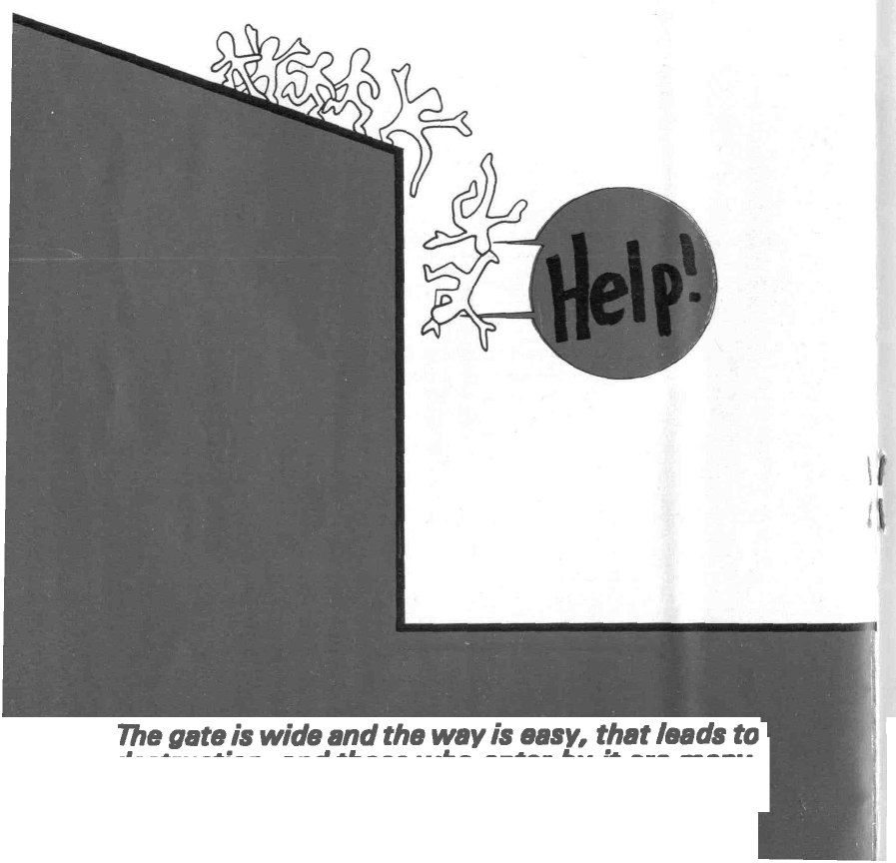
Matthew 7, verse 13

NOT EVERYBODY WANTS HELP
The nations who will oppose Jesus
would prefer to do things their own way, and remain in control,
even when they see
no way out of the mess.
Many people are like that,
unwilling to be helped
unless things are really desperate.
DAY BY DAY PEOPLE FORGET
that things are really desperate, that we do need help, that we are all dying.
Long ago God said
that people who disobey His laws
^ will be punished by death.
f He ordered unconscious "sleep"
in the ground,
for all who deliberately ignore
; : '•', •"• His laws
and go their own way.
HUMAN NATURE MUST BE CHANGED
if the world is to become a place fit for God to inhabit.
Only the Bible can change
the way we think and act.
Only God has the power
to give us new life. Nobody else can solve our personal problems.
WE ARE ALL DYING
sooner, or later, : -
i some to sleep in the grave for ever;
some to awake from that sleep
and be made new people, to live in a new
and better
: ' , ' - •" society. . ;,:
THE CHRISTIAN BELIEVES
in a new life that will last for ever.
For Christ also died for sins once for all, the righteous for the unrighteous, that he might bring us to God.
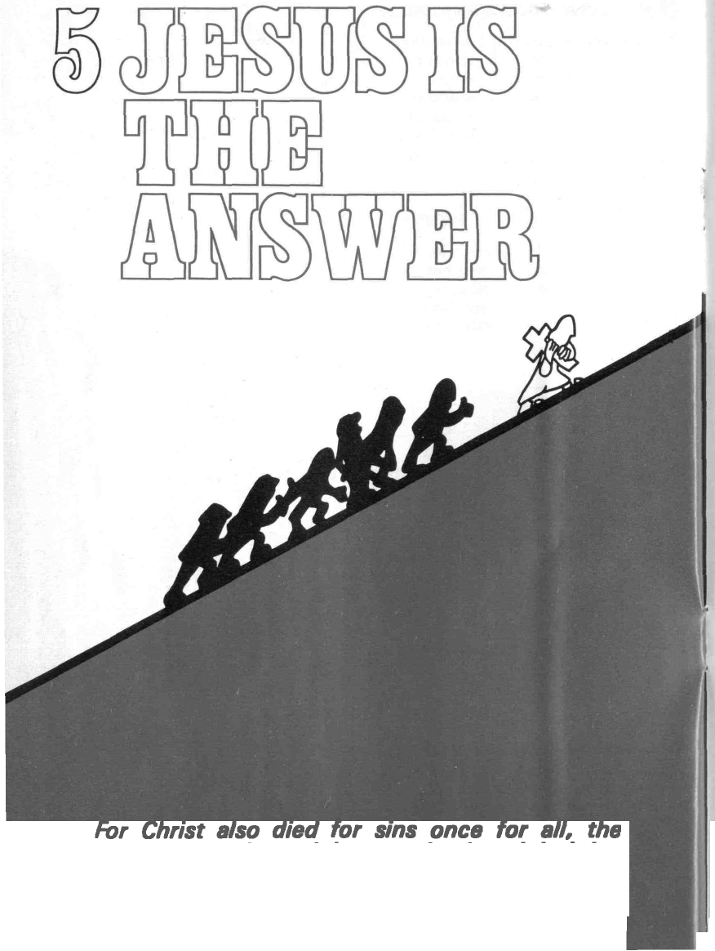
1 Peter 3, verse 18

WITHOUT JESUS THERE IS NO HOPE
of everlasting life. Only he can save us from sin and its effects.
For Jesus is no ordinary man. Born to a virgin by the power of God, he is the Son of God.
During his life on earth
He showed us what God is like. Sharing human nature with our potential for sin, he never once disobeyed his Father. He was sin-less in a sin-ful world. Jesus demonstrates the quality of life
that God wants from us.
BUT JESUS WAS MURDERED
by his fellow men; '•'..
not because he deserved to die
but because his perfect life
demonstrates our imperfection. His ordeal on the cross
exposes the truth . . .
that human nature is sinful
and deserves to die.
4 So God was shown to be right
' : when He condemned
* sinners to death.
WHEN GOD RAISED JESUS FROM THE DEAD
to inherit an endless life
He opened a way of escape for us.
Now there is a way to God, . :
for us to find,
* because of what Jesus has done.
JESUS HAS THE ANSWER TO OUR PROBLEMS whatever they are.
This Jesus who was taken up from you into heaven, will come in the same way as you saw him go into heaven.
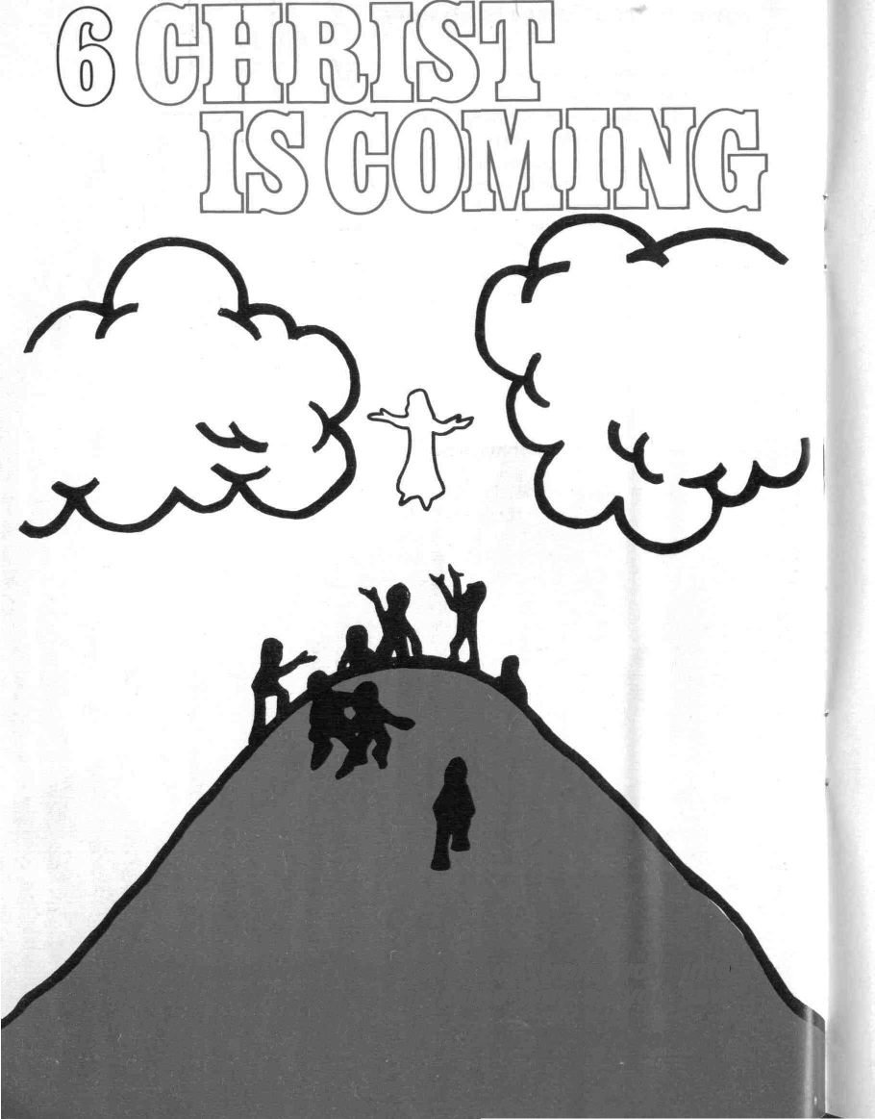
Acts 1, verse 77

ONLY ONE MAN HAS CONQUERED DEATH
to live forever.
Even his followers failed to believe
that he was alive. .
Until they saw Jesus,
touched him,
watched him eat,
, ' and were at last convinced
that he who had died was alive again,
and was given all the power of God in heaven and earth.
THERE ARE PEOPLE TODAY,
centuries later,
who believe that Jesus is still alive. Such people take God at His Word and await the return of Jesus
from heaven, to earth, to reign as king.
ASK ANY CHRISTADELPHIAN YOU MEET
to show you what the Bible promises and how it affects you.
Find out where their meetings are held and go along to see for yourself;
or write for some free Bible literature.
IF JESUS DOES NOT RETURN
there is no way out of the crisis, for the world or for you.
But he will come soon — to save his people.
. . they received the word with all eagerness,

examining the scriptures daily to see if these
things were so... Acfs 1?/ yerse „

IT WILL BE TOO LATE THEN
to decide that you believe these things. When Jesus returns
in power and great glory to fight at Jerusalem, to judge the world,
to right the wrongs; when every eye can see him
it requires no effort to believe.
READ THE BIBLE
NOW
*-Find out about Jesus,
about God's escape plan
and the answer to your needs.
* —Learn to talk to God in prayer
£ as you find out what He wants
| and what He offers.
i *—Discover the thinking behind
adult baptism by immersion
' and the sort of life that pleases God.
START TODAY
* —Get a Bible ••'.--
and look into it.
* —Check if this booklet contains true Bible teaching
by looking up the passages overleaf.
" Don't accept things second-hand;
find out for yourself.
*—Day by day explore the Bible and learn to live.
-s| Prepare today for the new life
* when Jesus returns to earth.

PREPARE TO MEET KING JESUS
CHECKLIST
1-THE WORLD IS IN A MESS.
2-GOD HAS HELPED OUT IN THE PAST.
3- GOD WILL HELP OUT AGAIN.
4-PEOPLE NEED HELP.
5-JESUS IS THE ANSWER.
6- CHRIST IS COMING,

7-YOU NEED TO BE READY.*

READING LIST
1-Luke 21 v 5-11, 25-28; 2 Timothy 3 v 1-5; Genesis 6 v 11-13; Matthew 24 v 37-42 and Revelation 11 v 18.
2 - Daniel 4 v 28-37; Exodus 19 v 3-6; Nehemiah 9 v 24-31; Deuteronomy 28 v 58-68 and Romans 11 v 1-2, 11-15, 25-27.
3-Jeremiah 32 v 37-44; Luke 21 v 24-27; Isaiah 2 v 1-5; Psalm 72 and Zechariah 14 v 1-5, 9-21.
4-Joel 3 v 1-2, 9-21; Genesis 3 v 1-19; Jeremiah 51 v 37-39; Daniel 12 v 1-3; 2 Peter 1 v 1-11 and Revelation 21 v 1-5.
5-John 3 v 14-17; Luke 1 v 26-38; John 1 v 14-18; Hebrews 2 v 14-18, 4 v 14-15 and Romans 8 v 3-6, 3 v 19-26, 5 v 1-2.
6-1 Corinthians 15 v 13-28, 50-58; Luke 24; 1 Thessalonians 1 v 9-10, 4 v 13-18, 5v 1-11; 2 Thessalonians 1 v 7-10 and Matthew 1 v 18-21.
7-Mark 13 v 24-27; Acts 17 v 30-31; Revelation 1 v 1-7; Romans 6 and 2 Timothy 3 v 14-17.

