CHRISTADELPHIAN BIBLE MISSION
The Acts of the Apostles
A CORRESPONDENCE COURSE
The Acts of the Apostles is the second book of the Bible written by Luke, the first was his gospel. In it he traces some of the important events in the early church, and shows how the "good news" of the Kingdom of God and of the Lord Jesus Christ spread outwards from Jerusalem into Asia Minor, northern Africa and into Europe.
In this Bible Correspondence Course you should read carefully through each of the chapters in the book of Acts, and then answer the questions which are set for the chapter. Please return your answers to your tutor. Write your answers on a piece of paper; there is no need to return the course sheets as well. You should head each set of answers as follows:
Your name........................................................ Reference number-Acts Course chapters:.......................................
Against each answer give the number of the question which you are answering. Each question starts with a letter Q.
The Authorised Version of the Bible has been used in the writing of this course, so you may find small differences if you are using a different version. They should not affect the meaning significantly.
################################################### Please return your answers to:
Acts Chapter 1
The Book of the Acts of the Apostles continues on from the Gospels (Matthew, Mark, Luke and John). Towards the end of the Gospels we have the sad account of the torture and crucifixion of the Son of God. But the Gospels do not end there.
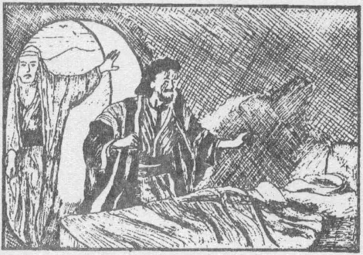
Q1.1 What great event happened
three days after the death of
the Lord Jesus Christ ? Q1.2 Write down some of the
many proofs the apostles
were given to show that
Jesus was alive (you will find
The tomb was empty!
it helpful to look at the end of
the Gospels for these). Q1.3 What did Jesus talk about to
his disciples during the period of forty days from his resurrection to his
ascension?
Q1.4 When the Apostles asked the Lord Jesus if he was going to restore (bring back) the Kingdom to Israel then
(a) what did they want? (verse 6)
(b) why didn't Jesus tell them when the Kingdom would be restored ? (verse 7)
Q1.5 In verse 8, what did Jesus tell the Apostles to do after they had received
the Holy Spirit? Q1.6 As Jesus was taken up into heaven angels spoke to the disciples and
said that Jesus will return again.
(a) Which verse says this? (Write it out.)
(b) What does it mean when it says 'in like manner' in this verse?
The Apostles were left without Jesus, and Peter talked about Judas Iscariot and how he betrayed Jesus and then committed suicide. The Apostle Peter said that there were references to Judas in the book of Psalms (Psalm 41:9; 69:25 and 109:8). These Psalms were written by David about 1,000 years before the time of Judas Iscariot.
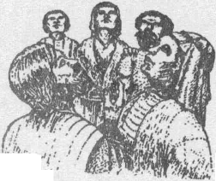
Q1.7 How was David able to prophesy like this?
Q1.8 Another Apostle was needed to take the place of Judas Iscariot. What do verses 21 and 22 say about that person?
Q1.9 What did the Apostles do before they cast lots to choose this twelfth person?
Mr-
Acts 1:10

NOTE : This chapter teaches several important things. Bible Teaching
1. | Jesus rose from the dead | verses 3, 22
2. | Jesus will return to the earth | verse 1 1
3. | The Kingdom of God will be set up with Israel as its centre | verses 3, 6
4. | Concerning the Holy Spirit this chapter teaches:
 | (a) It is the power of God | verse 8
 | (b) The Lord Jesus Christ possessed it | verse 2
 | (c) God spoke to His prophets through the Spirit | verse 1 6
 | (d) The Apostles would receive the Holy Spirit too | verse 5
 | (This happened at Pentecost as recorded in Acts 2)
 | (e) The Holy Spirit would help the Apostles in their
 | witnessing (preaching) | verse 8
###################################################
Acts Chapter 2
4 | • • - tv <jcj va -(Acts I v-i) | *
n BMMMJ | ib • • mm m m
 |  | i i
* _______ |  | \
[t  feath of JesuS | 50 day | L '  (Acts i rt.q-H)
on Pente cos"!
Time scale of events in Acts chapters 1 and 2
Copy out this passage filling in the blanks as you do so. You may need to put more than one word for some blanks.

_ were filled with the Holy Spirit and _____ so that the crowd who spoke
Q2.1 On the day of Pentecost, the.
they were able to speak with other ____ many different languages could all understand. Some people thought the Apostles were ___ that God had poured out His ______ as the prophet said He would.
but Peter told them ____had
____ (verse 22), thatthey had.
.him,
He told them about ______
but God had ______ him from the dead, even as God said He would hundreds of years before, when He inspired David to write the words: "Thou wilt not leave my soul in hell, nor let your _________ see ______"
(verse 27 and Psalm 16:8-11).

This could not refer to David himself, because David did.
and
his grave could still be found at that time, but because David was a prophet, he was here speaking about the resurrection of _______ as verse 31
says.

Peter was telling them that they (the Jews) had put Jesus to death, but God had raised him from the dead and raised him to His right hand. Then Jesus had sent the Apostles the Holy Spirit as He had promised (verses 32-36).
Q2.2 Why didn't the Lord Jesus Christ remain dead?
Q2.3 What did Peter tell the people they should do?
Q2.4 What did those who were baptised do together?
Important points to notice from this chapter are listed below:

ABOUT JESUS
3.
4.
5.
6.
7.
8.
(a) He was a man, who was approved of God. He was not,
therefore, equally important as God. verses 22, 30
(b) Jesus had to die. This was part of God's plan. verse 23
(c) Jesus was raised from the dead. verses 24, 27, 31-32
(d) After his resurrection he was exalted by God
and given power. verse 33
(e) Salvation is only obtained through the name of Jesus. verse 21
(f) Jesus was the Christ, which means the one anointed
to be king, or MESSIAH. verse 36
God made promises to David that His son (Jesus) verses 30-31
would reign on His throne (that is, he would reign
from Jerusalem). See also 2 Samuel 7:12-16
Even good people, like David, do not go to heaven. verse 34
'Soul' means living person. verse 41
'Hell' means the grave, so verse 31 means that Jesus verse 31
did not stay in the grave.
verses 38, 41
Those who want to come to Christ and be like him must first REPENT and then be BAPTISED.
Baptised believers must remember the Lord Jesus' death by breaking bread together.
verse 46
ABOUT THE HOLY SPIRIT
(a) This chapter tells us that Jesus received it.
verse 33
verses 1-4,16-18 verse 38
(b) The Apostles and early disciples also possessed it.
(c) The early believers received this power.

(d) The Holy Spirit helped the disciples to speak in tongues.
verse 4

VERSE 31
We are told that Christ's soul was not left in hell, neither did Christ's flesh see corruption. So Christ's soul went to hell.
What is hell? The word 'hell' could have been translated 'grave' or 'covered place'. So it could have been said Christ's soul was not left in the grave.
But what does it mean when it says his 'soul'? Since it says it went to the grave, it cannot mean an immortal (undying) part of the Lord Jesus Christ. The Bible NEVER talks about an 'immortal soul'. 'Soul' means life or person. So when it talks about his soul, it means the Lord Jesus Christ himself.

Christadelphian Bible Mission
Bible Study Course - Acts

This verse simply means that the Lord Jesus Christ did not stay in the grave. What else can it mean? And the second part ('neither did his flesh see corruption') shows that the actual flesh of the Lord Jesus Christ did not rot and decay, because he was raised up by God (verse 32).
VERSES 42 AND 4S-What is the "Breaking of Bread"?
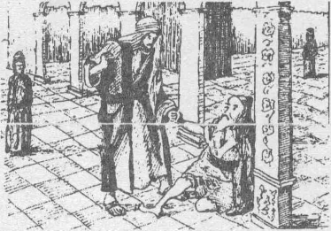
We are told that Jesus commanded his followers to remember his death by breaking bread (Read 1 Corinthians 11:23-34).The bread was a symbol of his body, the wine was to help them remember his blood. The bread did not turn into his body. How could it when he was there alive with them, telling them to eat the bread? Neither did the wine turn into his blood. They are symbols to help believers remember the sacrifice that the Lord Jesus made (1 Corinthians 11:26).
Acts 3:1-8
###################################################

Acts Chapter 3
Q3.1 Q3.2
Q3.3
Q3.4
Q3.5
By whose power did Peter and John do this miracle? Please copy and complete:
Again, Peter tells them that they killed Jesus (the Prince of. but wanted a ______ to live. He tells them again to _.
J,
and be converted.
Verses 20 and 21 say: 'He shall send Jesus ... whom heaven must
receive until the times of restitution of all things".
Does this mean:-
(a) Jesus has gone to heaven for ever, OR,
(b) Jesus will be sent back to earth after a certain time? OR
(c) Jesus will rule over the earth from heaven after a certain time?
Verse 25 refers back to one of the promises which was made to Abraham
(see Genesis 12:3). In what way would Abraham's seed (the Jews) be
blessed?
What does 'repent and be converted' mean?

Some important things this chapter teaches us are:

1 Jesus is the Son of God.
verse 13,26
verses 15,18,26
verse 22
2 He had to die and was raised from the dead.
3 The teaching of Jesus is very important. (Jesus was the one referred to by Moses in Deuteronomy 18:15-18)
4 Jesus will return to earth verse 20,21
5 God made promises to Abraham which were to be fulfilled verse 25,26
(completed) through Jesus (the 'seed'). (Jesus was in God's
plan when He made the promises to Abraham). See Genesis chapter 12
6 The SOUL CAN DIE. ('Soul' means life or living person) verse 23
7 People who come to Christ must first repent. verse 19
8 People who do not listen to God and read His word verse 23
will be destroyed.

Christadelphian Bible Mission
Page 5
Bible Study Course - Acts
NOTE:
Verse 22 is a prophecy about Jesus (see Deuteronomy 18:15,16) Jesus was the prophet raised up by God. Note it says 'of your brethren' or 'from among your brothers.' This again shows that Jesus, before his death, was a man, with human nature. (See Acts 2:22: Jesus, a man approved of God).

###################################################
Acts Chapter 4
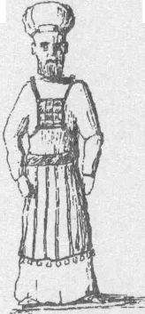
Q4.1 Why were the leaders of the Jews cross with Peter and John (verse 2)?
Q4.2 Verse 11 - The stone is the Lord Jesus Christ (see also Matthew 21:42; Psalrn 118:22 and 1 Peter 2:5-9). What happened first of all to the stone?
Q4.3 What is meant by 'has become the head of the corner'? Q4.4 Verse 12 - What is the only name by which we can be
saved? Q4.5 Romans 13:1 -7 says we should obey our rulers. Why
were Peter and John right in disobeying the chief priests
A High Priest (see Acts 4:6)
and elders? (See also chapter 5:29).
Read verses 25 to 28 and then read Psalm 2. The Psalm was written about 1,000 years before the time of Jesus and yet it says that the people and rulers would come together against God's anointed (Messiah), that is, against Jesus (Psalm 2:2). So what happened to Jesus was no accident. Itwas part of God's plan and He had said, long before, that it would happen (Acts 4:28).
Verse 31 records another outpouring of the Holy Spirit and so the believers spoke the word of God and were united and gave willingly.
###################################################
Please return your answers to:
Please include your reference number which is:.

Christadelphian Bible Mission
Bible Study Course - Acts
Page 6

CHRISTADELPHIAN BIBLE MISSION


The Acts of the Apostles
• !;,:\ • - - "..-=;"•,. ' .
###################################################
Acts Chapter 5
Q5.1 Ananias and Sapphira gave money to the Apostles. They were punished because they said they had given ALL the money to the church. To whom were they lying?
Q5.2 The Apostles were able to do many wonderful things (see verses 12-16) by the power of the Holy Spirit.
(a) Did their healings ever fail?
(b) What effect did all this have on the High Priest and the Jewish leaders? Q5.3 Who helped them to get out of prison and what did he tell them? Q5.4 What did Peter tell the chief priests (and others) about....
(a) who killed Jesus?
(b) why Jesus was raised and exalted?
Q5.5 What did Gamaliel say (verses 38-39)? „
Q5.6 What effect did all this have on the Apostles (verses 41-42)?
Verse 29 says 'we ought to obey God rather than men'. The Apostles could not obey the authorities if it meant they were disobeying God. We should obey our leaders unless they are asking us to disobey God.
Verse 31 tells us that there is forgiveness of sins through the death of Jesus.
ANGELS—Angels are God's messengers, who always do what He wants. They help those who trust in God and who accept His salvation (see Hebrews 1:13-14; Psalm 34:7). Angels do not marry (Matthew 22:30), and those who have a place in God's Kingdom will be made like the angels and therefore will not die.
WHAT ARE 'UNCLEAN SPIRITS' OR 'DEVILS' (Acts 5:16)?
Obviously unclean spirits are to do with illness because verse 16 says "and they were HEALEDevery one". If you look at Matthew 8:16,17 you will see that this is so. "When the even was come, they brought unto him (Jesus) many that were possessed with devils, and he cast out the spirits with his word, and healed all that were sick."
Matthew 8:17 says that he did this to fulfil what Isaiah had prophesied about him: "Himself (Jesus) took our infirmities and bare our sicknesses." So the 'casting out of devils' in verse 16 is the same as Jesus 'taking our infirmities and sicknesses' of verse 17.
So why does Scripture use the term 'unclean spirit' or 'devils'?
1. It is nothing to do with the devil because the words in Greek are quite different. The Greek word forthe devil is DIABOLOS and it is used of sin. The Greek word for devil (or unclean spirit) is DAIMONION, and is used of mental illnesses, etc. (The word DAIMONION is translated 'demon' in some versions).
Christadelphian Bible Mission S|| Page 7 Bible Study Course - Acts

2. The people of the time could not explain illnesses such as dumbness, epilepsy, deafness, because there seemed to be no reason for them. They could understand that a man could be lame if one leg was shorter than the other, but they could not understand mental illness etc. So they said the person had a demon (or was mad). They even said this of Jesus (John 8:48-52) because they could not understand his power and teaching.
We are told what was wrong with those who had demons in Matthew 9:33 and Matthew 17:14-18. Look them up and find out.
###################################################
Acts Chapter 6
Some believers were worried because so much time was spent on preaching that things like looking after widows were not being done. So seven men were chosen to look after the needs of the poor. One of these men was Stephen.
Verses 3 and 8 again show us that the Holy Spirit is the power of God, which allowed Stephen to do t
signs, miracles and speak with great vision. Although he had been chosen to look after the
widows, he could not stop preaching about Jesus.
JESUS AND THE LAW GOD GAVE MOSES
God gave a law to Moses for the people of Israel. He gave the ten commandments at Mount Sinai, -
and other laws about how the people should worship God and how they should live. To
the Jews this law was most important, although they did not keep it properly (see Matthew 23,
especially verse 23). . , .
Much of the law wasto teach them about the things of God andto preparethe peopleforthe Lord Jesus Christ. Galatians 3:24 says "The law was our schoolmaster to bring us to Christ, that we might be justified by faith". The law was to last only until Christ: Galatians 3:25—"But after that faith is come, we are no longer under a schoolmaster." Also verse 19 of the same chapter: "Wherefore then serves the law? It was added because of transgressions (sins) TILL the seed should come to whom the promises were made ....;" The seed to whom the promises were made was, of course, Jesus.
Since the time of Jesus, people have not had to keep the law given by God to Moses, although its ideals are excellent, as Jesus showed in Matthew 5:17-48. The first century Jews found it very difficult to accept that the law, with all its sacrifices and ceremonies, did not now apply and some tried to force Gentiles to keep the law. This is what the big meeting in Chapter 15 is all about. . .
In what way was the law a schoolmaster to bring the people to Christ?
It showed people what sin is so that they knew when they were sinning. It also showed that a sacrifice was needed to'cover'their sin.
People who come to Jesus need to be aware of their sins and accept the sacrifice he made for us when he died for our sins.
Why is the Law no longer needed?
Because the one sacrifice of a totally sinless man (Jesus) is enough for all people to have their sins forgiven (See Hebrews 9:24-28, especially 28).
Christadelphian Bible Mission & a Page 8 Bible Study Course - Acts

How can we have our sins forgiven?
We have to repent and be baptised because baptism washes away our sins (Acts 22 v 16) and also ends the old life of serving ourselves and starts a new life of serving God. So we are 'baptised into the death of Jesus Christ.' (Read Romans chapter 6). Q6.1 Why did Stephen get into trouble?
###################################################

Acts Chapter 7

Stephen reminds the people of God's dealings with the Jewish nation, starting with the first Jew, Abraham. Read the chapter carefully, then re-read it as you try to answerthefollowing questions. (Thesum-mary atthe end may help you, and Genesis chapter 12 and chapter 13 will also be useful in answering the first few questions).
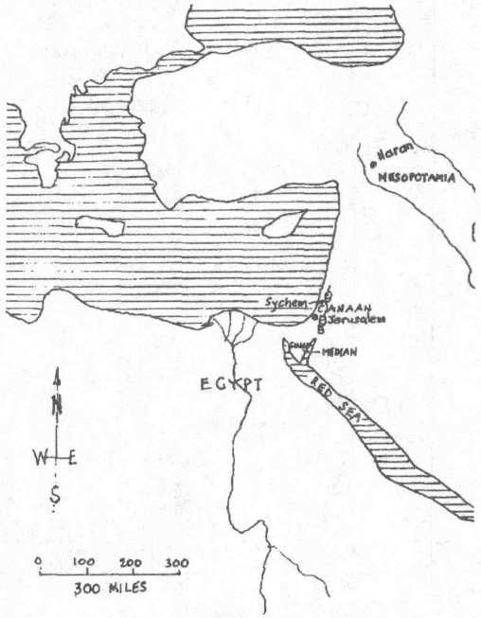
Q7.1 Where did Abraham first live?
Q7.2 What did God tell him to do?
Q7.3 What did God promise to give Abraham?
Q7.4 Did Abraham receive what God has promised him?
Q7.5 Why did Joseph go Egypt?
Q7.6 Who helped Joseph when he was in Egypt?
Q7.7 In which land was Moses bom?
Q7.8 What was Moses told at the burning bush?
Q7.9 Why did 'God give them up to worship the host of heaven'? (verse 42)
Places mentioned in Acts 7.
Q7.10 Where does God dwell (live)?
Q7.11 Why were the people angry (verse 54)?
Q7.12 What did Stephen see just before he died?
Q7.13 What did Stephen say just before he died?
Q7.14 Why does it say'he fell asleep,'in verse 60?
God told Abraham to leave home, and Abraham did what he was told. Because he obeyed, God made promises to Abraham, and one of these promises was that Abraham would inherit (own) the land that God showed him (now known as Israel).
Verse 5 says that Abraharh did not have that land while he was alive, even though God has promised it to him. So when will Abraham have the land?—when he has been raised from the dead, when Jesus

Christadelphian Bible Mission
Page 9
Bible Study Course - Acts

has come back to this earth.
Note that Abraham was promised land (Israel) on this earth, not a place in heaven. The Kingdom will be on the earth, and then God will give to Abraham what He has promised him.

Abraham
had a son called
Isaac
who had a son called
Jacob
who had 12 sons
one was
I I I called
Judah Levi (etc) Joseph
Abraham obeyed God and God was pleased with h i m and made special promises to him.
Isaac was also promised blessings by God (but not Ishmael).
Jacob was given the name 'Israel¹, and so his descend-ents are known as the children of Israel.
Joseph was hated by his brothers and sold as a slave. Later he became second in command in the land of Egypt.

I
David
Solomon
Moses was descended from Levi
Moses was bought up as an Egyptian prince. God chose him to deliver the people of Israel from Egypt. Moses was given the 10 commandments.
David was the king God chose to rule over the people of Israel.
Solomon built the temple for God.

##################################################
Acts Chapter 8
Note that Saul was mentioned in chapter 7:58.
Q8.1 Copy out this passage filling in the blanks as you do so. You may need to put more than one word for some blanks.
After the death of Stephen, most of the Christians in ______ were persecuted and were scattered. The ______stayed in Jerusalem. But as the Christians were scattered, so they took the gospel message to others further away.
Philip (not the Apostle Philip but one of the seven deacons, Acts 6:5) preached in ______ and the people, when they heard him and saw the

Christadelphian Bible Mission
Page 10
Bible Study Course - Acts

______ he did, followed him. When they believed what Philip taught them about the Kingdom of God and the name of ______ they were baptised, both ______ and ______ (verse 12). Simon the magi-
cian also
and was

The Apostles Peter and John came from.
to these new believers
at Samaria and they prayed that the newly baptised people should receive the ______ and so they laid their hands on them. Simon offered the apostles ______ because he wanted this power to be able to give people the ______ but Peter told him ______.

PHILIP PREACHES TO AN ETHIOPIAN (Chapter 8:26-40)
Q8.2 Who told Philip to go to the road from Jerusalem to Gaza?
Q8.3 The man from Ethiopia
was reading from Isaiah
^ chapter 53. What is Isaiah
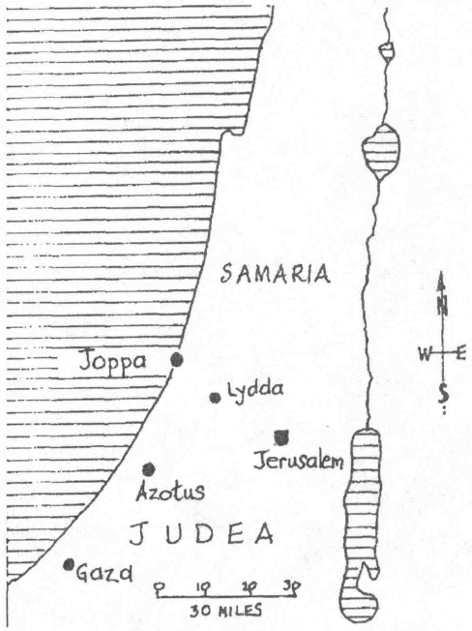
53 about? Q8.4 What did Philip say to the
Ethiopian when he asked
to be baptised? Q8.5 What did they both do in
order that the Ethiopian
could be baptised?
Q8.6 Howdoyouthinkthisman was baptised—by sprinkling water on him, or by putting him down under the water?
The first part of this chapter shows us:
1. Men and women (not children) were baptised after believing what Philip taught
x about the Kingdom of God and about the work of Jesus.
2.
The preacher Philip (not the apostle Philip) did not seem to be able to give people the gift of the Holy Spirit, although he had baptised them with water.
Places mentioned in Acts 8

The Apostles could give people the gift of the Holy Spirit after they had prayed and laid their hands on them.
3.
4.
Simon, even after he had received the Holy Spirit, still did not have the power to give it to others. This is what he wanted Peter and John to give him.

To sum up:

It seems that only the apostles (and God and Jesus) had the power to give the gift of the Holy Spirit to others, so that when the apostles died there would be nobody to pass on the gift of the Holy Spirit.

Christadelphian Bible Mission
Page 11
Bible Study Course - Acts

BAPTISM
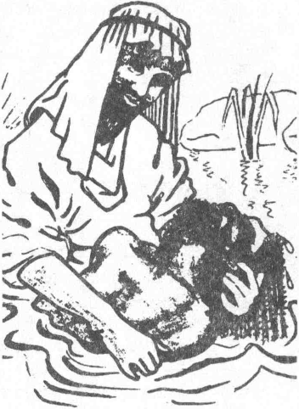
The Ethiopian had been learning about the Lord Jesus Christ and his death, and asked to be baptised. Verse 38 says "they went down both into the water, both Philip and the eunuch; and he baptised him." Verse 39 says "when they were come up out of the water....."
Baptism is a complete burial in water (putting completely under the water). The eunuch had to believe first before he could be baptised. Babies should not be "baptised" because they cannot repent of their sins. The Bible does not talk about babies being baptised. This is something men have made up and is not part of God's truth.

Philip baptising the eunuch

###################################################
Please return your answers to:
Please include your reference number which is:.

Christadelphian Bible Mission
Page 12
Bible Study Course - Acts

CHRISTADELPHIAN BIBLE MISSION


The Acts of the Apostles
###################################################
Acts Chapter 9
Saul had watched while Stephen was stoned (chapters) and was persecuting (trying to kill or imprison) Christian believers.
Q9.1 Who had given Saul permission to persecute the believers at Damascus
(verses 1,2)? Q9.2 The Lord Jesus Christ spoke to Saul, in verses 4-6. What was he telling him?
Saul was now certain that the Lord Jesus Christ had been raised from the dead. Now he knew that he had been wrong to persecute the followers of Christ. He had to repent.
Q9.3 For how many days did he go without food and drink?
Q9.4 Why didn't Ananias want to go and look for Saul?
Q9.5 What did the Lord Jesus teil Ananias about Saul?
Q9.6 What did Saul do after Ananias had healed him?
Q9.7 What did Saul immediately preach about?
Verses 23-30 tell us some of the troubles Saul had during his first few years as a follower of Christ. These were only a few of the troubles he suffered.
Q9.8 By whose power was Aeneas healed?
Q9.9 This power was so great that by it Peter and John could even raise the dead. What was the name of the person brought back to life in this chapter?
Q9.10 Can people do miracles like this today, as Peter and John did? (see note on the Holy Spirit in chapter 8).
###################################################

Acts Chapter 10
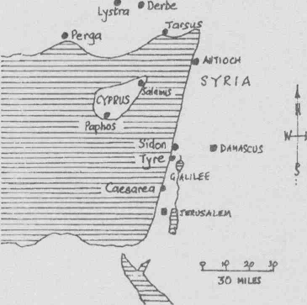
.Iconi'uw
Until this time the early church was made up of Jewish Christians only. The Jews hated Gentiles (non-Jews), so they did not think God could possibly want to save Gentiles. But God wants Jews and Gentiles to turn to Him. So the Jewish Christians had to be told by God that it was His will that the Gentiles should be saved. Peter was one of the most important of the apostles, and so he was chosen by God to help Cornelius. Q10.1 What sort of person was Cornelius?
Q10.2 Why wouldn't Peter eat any of the animals that he saw in the vision? (see also Leviticus chapter 11).
Q10.3 What was the reason for Peter's vision?(see verses 15, 28, 34 and 35).

Places mentioned in Acts 9-13

Christadelphian Bible Mission
Page 13
Bible Study Course - Acts

Q10.4 What does Peter tell Cornelius about Jesus:
i) in verse 36?
ii) in verse 38?
iii) in verse 41?
iv) in verse 42?
v) in verse 43?
Q10.5 What did Jesus command the apostles to do? (verse 42) Q10.6 What happened while Peter was talking?
Cornelius and the other believing Gentiles received the gift of the Holy Spirit before they were baptised. This is the only time we read of the Holy Spirit being given before baptism. It showed Peter that Gentiles could also become true followers of the Lord Jesus. So Peter told them they could be baptised. This is the first time that Gentiles were baptised.
####################################################

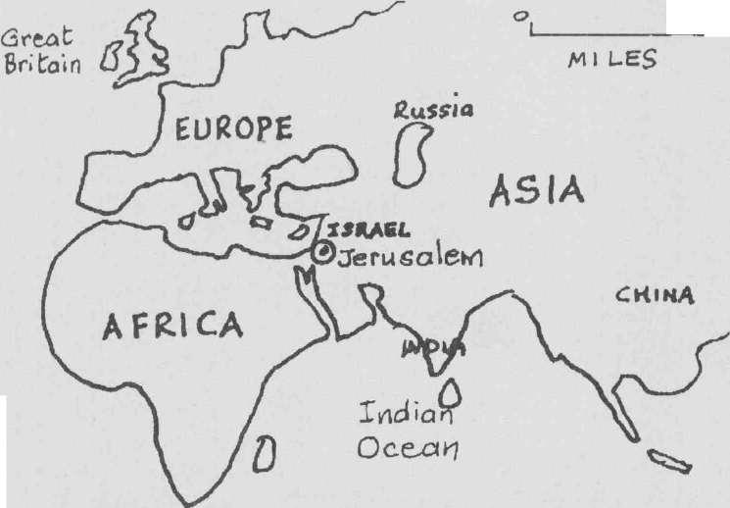
toep
Vf-E
Atlantic Ocean

Where Jerusalem is on irhe^ world map...

Christadelphian Bible Mission
Page 14
Bible Study Course - Acts

QUESTIONS AND THEIR ANSWERS

Why did Dorcas die? Why do we die?
Q
A Because we all sin, that is, we all disobey God.

Q
Where did sin come from?
A Adam and Eve first sinned when they disobeyed God's command not to eat of the fruit of a certain tree. Their punishment was death. We all die because we are descended from Adam, and like him, we all sin (read Romans 5:12).

What do you think happens to a person when he dies?
Q
A The life processes stop and then gradually the body begins to decay (rot).

Q
Don't you believe your soul will go to heaven when you die?
A No, this is one of the wrong beliefs that men have made up. The Bible does not speak of immortal souls, and when the Bible uses the term 'soul' it means 'life' or 'person', for example: "The soul that sins, it shall die" (Ezekiel 18:4). This means that the person who sins will die, and that includes everyone. There is no need for anyone to go to heaven since the Lord Jesus Christ is coming back to this earth.
Q So we are all going to die, and death is the end of everything. Not very cheerful, is it?
A Well you would be right if it wasn't for the one person who broke the rule.
Q What rule?
A That all men sin and therefore all men die. The Lord Jesus Christ never sinned, even though he was very sorely tempted. He was completely obedient to his Father. Because he did not sin he did not deserve to die.
Q Ah, but he did die, didn't he?
A Yes, but he did not stay dead, because he had conquered sin. He broke the rule—that sin leads to death. He was raised from the dead with an immortal body, one which will never again die. (Read Acts 2:24; 1 Corinthians 15.)
Q But how does this help us?
A If we have truly committed our lives to God and been sorry for our sinfulness, then our sins will be forgiven and we will no longer be 'sentenced to death'. Then we too will be raised from the dead when the Lord Jesus returns to this earth. Wewill begiven immortal life, and live on this earth underthe kingship of Jesus Christ.
Q But how do we commit our lives to God?
A We try to follow the Lord Jesus Christ. He was baptised as an adult, and so we, as adults, should be baptised and then follow his example of love and self-sacrifice in serving God.
Q But what is baptism, and why do Christ's followers today have to be baptised? A Baptism is acomplete burial in water. Romans chapter6tells usthatjust as Jesus died, and was buried, so we must die, in symbol, by being buried in water, and then, as Jesus rose to a new life so we should leave behind our old sinful ways and start a new life of serving God. Our sins are removed by baptism, and, unless our sins are removed, we will not have life after death. So yes, there is hope beyond the grave!

Christadelphian Bible Mission
Page 15
Bible Study Course - Acts

Acts Chapter 11
In verse 2 it says Ihey that were of the circumcision". This refers to Jews. In verse 3 where it says "men uncircumcised" it means Gentiles.
From Abraham's time all Jewish baby boys were circumcised. In Genesis 17:10-14 we find that circumcision was given to show thecovenant (agreement) God made between Himself and Abraham, the father of the Jews.
In this chapter we find that Peter had to convince the Jewish Christians that it was right to baptise Cornelius.
Q11.1 What eventually convinced them? (verses 15-18)
Q11.2 Finish this: "Then hath God also to the Gentiles ______
Q11.3 Where were the disciples first called Christians?
Q11.4 What did Agabus prophesy would happen?
Q11.5 What did the Christians do because of Agabus's prophecy?
Although Cornelius was obviously a very good man (chapter 10:2) he still needed to be baptised. Even though he was baptised by the Holy Spirit (see chapter 10:45 and chapter 11:16), he still needed to be baptised with water (chapter 10:47,48) so that he could have his sins washed away and start a new life. Chapter 11:18: "Then has God also to the Gentiles granted repentance unto life".
####################################################
Acts Chapter 12
Q12.1 Who was killed by Herod?
At the time of the Passover (Easter), Peter was imprisoned. Notice that Peter was sleeping when the angel came to rescue him. He could sleep because he had confidence that his life, whatever would happen, was in God's hands. He would not be afraid to die.
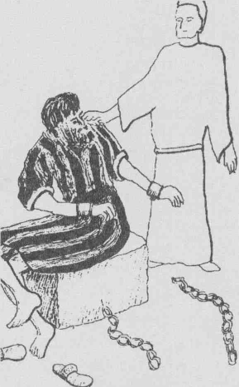
Q12.2 How did Peter get out of prison?
Q12.3 What were the believers at John Mark's house doing?
Q12.4 Why was Herod killed? (Give at least 2 reasons.) Q12.5 What does the chapter teach us about the way we should live our lives?
A point to note:
This Herod was the grandson of another cruel Herod, Herod
the Great (Matthew 2:16).

Peter is rescued from
prison by an angel
Acts 12

###################################################
Acts Chapter 13
Q13.1 What do we already know about Barnabas? (see Acts 4:36-37; 9:27; 11:22-
25; 12:25). Q13.2 What do we already know about Saul? (See Acts chapter 9.)

Christadelphian Bible Mission
Page 16
Bible Study Course - Acts

Q13.3 What had the Lord Jesus told Ananias about Saul? (Acts chapter 9:15)
Barnabas and Saul were sent out by God to preach in other countries. They started from Antioch (in Syria) and went to the island of Cyprus (to Salamis and Paphos). Then they went on to Perga in Pamphylia, Antioch (a different one), Iconium, Lystra and Derbe. They returned the same way except that they did not visit Cyprus.
Note that Barnabas was from Cyprus (chapter 4:36), so they started preaching in his homeland.
Q13.4 In what verse, at the beginning of this chapter, is Saul also called Paul?
Q13.5 What did Elymas (Bar-jesus) try to do?
Q13.6 What happened to him?
Notice that John Mark had been travelling with Paul and Barnabas until now, but leaves them (verse 13). John Mark was a relative of Barnabas (Colossians 4:10) where he is called Marcus. We first read about him in chapter 12:12.
Q13.7 To whom did Paul and Barnabas preach first: Jews or Gentiles? Q13.8 Was it the Jews or Gentiles who did not like Paul?
(REMEMBER: Jews are the descendants (children) of Abraham and Isaac. Gentiles are all people who are not Jews. Most of us are Gentiles).
PAUL'S SPEECH IN ANTIOCH (Pisidia) (verse 16 onwards)
Notice how Paul shows that God was in control of what happened to Israel. Verse 17 says:" ..... God ..... chose our fathers" and "He brought them out of Egypt".

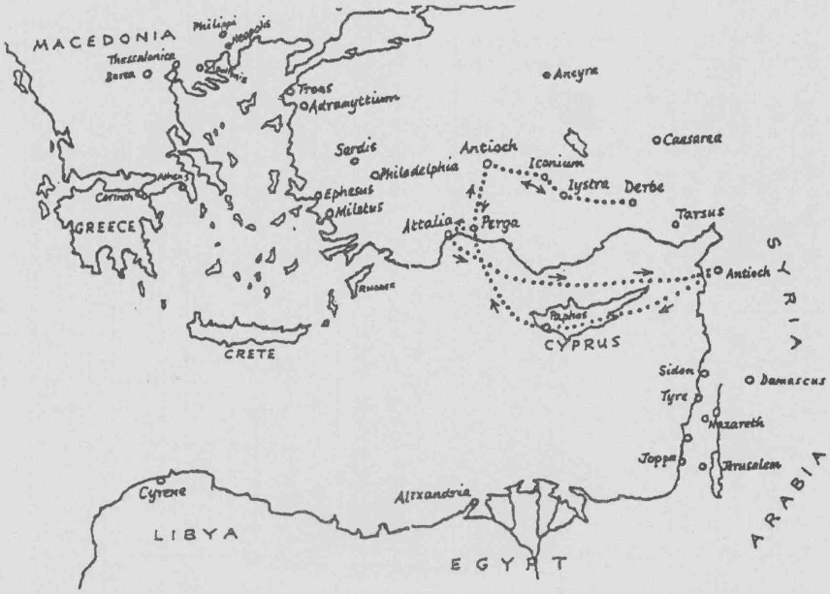

Paul's First Journey - Acts 13

Christadelphian Bible Mission
Page 17
Bible Study Course - Acts

Q13.9 Complete these:
verse 19 says God ______
verse 20 says God ______
verse 21 says God gave them their first king called
(iv) verse 22 says God removed him and gave them ______ to be their king.
(v) verse 23 says God raised them up a Saviour called ______ who was the seed of _______ as He had promised (2 Samuel 7:12-16).
Not only was God in control of what happened, but He wrote about many of these things in advance, e.g. the birth of Jesus and his resurrection are prophesied in the Old Testament. Also the fact that his flesh would not corrupt (rot) (see verses 34-37). This shows that God must have inspired the Old Testament writers.
God also knows in advance who will turn to Him (see verse 48). This doesn't mean that these people are forced to believe. We all have a free choice as to whether we will obey God or not, but God knows which we will choose because He knows everything.

A few other points to note in this chapter:

1 Jesus was sinless (verse 28)
2 There is forgiveness of sins by belief in Jesus (chapter 13:38) and forthose who fear God (verse 26)
3 The Jews were given the first opportunity to follow Jesus, but most of them rejected him. Paul therefore turned to the Gentiles (see verses 46,47).
4 Verse 31—Witnesses: we are not expected to believe fables or anything false. The Apostles were chosen to preach about Jesus because they had actually been with him, heard his words and seen his miracles, and were witnesses of his resurrection (Acts 2:22; 4:33; and 5:29-32)

################################################### Please return your answers to:

Please include your reference number which is.

Christadelphian Bible Mission
Page 18
Bible Study Course - Acts

CHRISTADELPHIAN BIBLE MISSION


The Acts of the Apostles
###################################################
Acts Chapter 14
Paul and Barnabas had now reached Iconium ontheirfirst missionaryjourney. Here they went straight away to the synagogue to preach to the Jews.
Q14.1 What did the unbelieving Jews do?
Q14.2 Why did Paul and Barnabas move on to Lystra?
Paul healed the lame man and then the people of Lystra thought he and Barnabas must be gods, and not just men.
Q14.3 What did they want to do to please these "gods"?
Q14.4 How did Paul describe the true God to these idol-worshippers?
Soon after this the people stoned Paul. This shows how easily people can be led into evil. We must take care that we do not listen to people of evil purpose, and join with the crowd. We remember how the people of Jerusalem welcomed Jesus into the city and shouted "Hosanna" and yet within a week they were shouting "Crucify him".
Q14.5 With God's help, what did Paul do after he had been stoned?
Notice the courage of Paul and Barnabas. They went back through those places where their enemies lived so that they could help and encourage the believers there.
Q14.6 What did they do when they returned to Antioch at the end of their first missionaryjourney?
(The word "rehearsed" in verse 27 means they "told" or "described").
###################################################
Acts Chapter 15
Verse 5 shows that some of the Pharisees wanted all believers to: i) be circumcised, ii) keep the Law of Moses.
(Look back at the notes with chapter 6 to remind yourself about the Law of Moses).
Q15.1 Who was the first person told to be circumcised? (Read Genesisl 7:9-27).
Christadelphian Bible Mission $|| Page 19 Bible Study Course - Acts

Q15.2 What was to happen to anyone not circumcised? (Genesis 17:14)

As well as being the sign of the covenant God made to their father Abraham (Genesis 17:10) and his descendants, it also taught that the Jews were not to be proud of their literal, fleshly descent from Abraham. As the Lord Jesus said "The flesh prof iteth nothing". The Jews were so proud of being children of Abraham that they despised all non-Jews (Gentiles), which was very wrong.
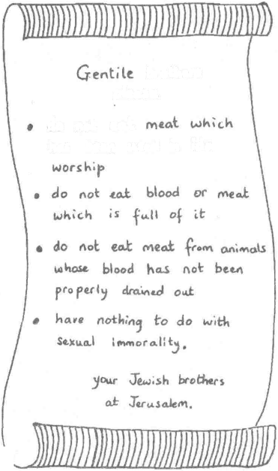
brothers please
do not e«,t
ho-£ beert ixJtol in idol
It is interesting that circumcision was to be done on the eighth day. This is when the baby's blood is best for clotting, and therefore healing.
The result of thei r discussion at Jerusalem was that they decided the Law of Moses did not have to be kept. Peter said that even the Jews couldn't keep the Law (verse 10) so why should Gentile believers be forced to observe it. In fact, the Gentiles did not need the Law because they could be saved by the grace of the Lord Jesus Christ (verse 11). "Grace" means 'free gift' and is totally undeserved. So we cannot EARN our salvation, but it is GIVEN by God, even though no one deserves it.
Q15.3 Write out verse 11.
Q15.4 What did Paul and Barnabas tell the
people? ^
Q15.5 Which verses Iistthe4things the Gen
tiles should keep from the Law of Moses?
What does verse 18 show?
Q15.6 Q15.7 Q15.8
What did Paul and Barnabas quarrel about?
Verse 40 is the start of Paul's 2nd missionary journey. Who went with him?

#####################################################
Acts Chapter 16
Q16.1 In chapter 15 the Apostles and elders of the early church decided circumcision was not necessary for salvation, so why did Paul circumcise Timothy?
Notice from verses 6-8 Paul was clearly shown where he should preach. See map. Q16.2 What was Paul told in a vision?
Notice in verse 8 it says "they....." and in verse 10 it says "we.....". It is thought that at this point Luke joined Paul, and Luke is the one who was writing by inspiration this book of the Bible.
Q16.3 WhowasLydia?
Q16.4 What did she do?
Q16.5 Why were Paul and Silas brought to the magistrates?
Q16.6 What did Paul and Silas do while in prison?
Q16.7 Why did the jailor want to kill himself?
Q16.8 What did the jailor have to do to be saved?
Q16.9 What did Paul and Silas do before the jailor had even washed their wounds? (verse 32).

Christadelphian Bible Mission
Page 20
Bible Study Course - Acts

Paul's Second Journey ________ (Acts 16) & Third Journey.
(Acts 18)

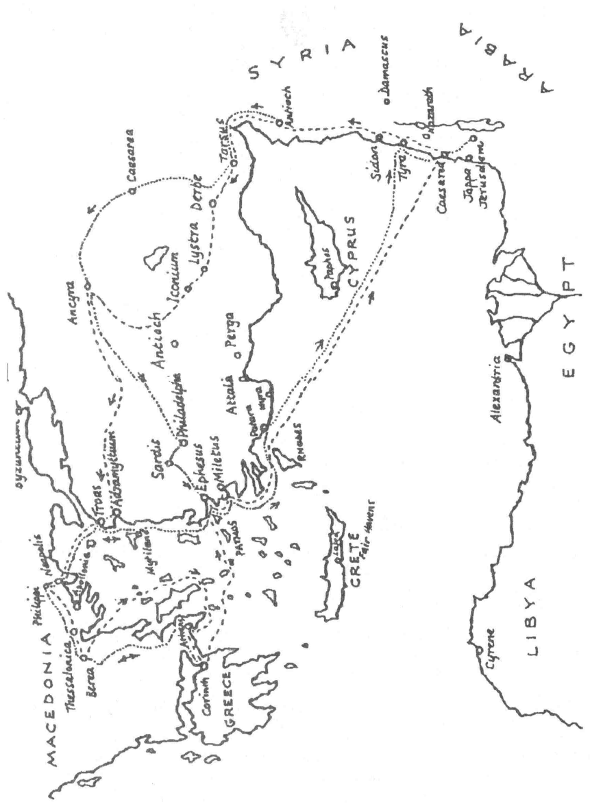

Christadelphian Bible Mission
Page 21
Bible Study Course - Acts

POINTS TO NOTE

1. If a Roman guard let his prisoner escape, he would be put to death; so the jailor thought it would be better to kill himself than let the cruel Romans do it. Paul saved him from this.
2. Paul could have said he was a Roman citizen earlier and escaped the flogging and imprisonment, but he wasn't one to stand up for his rights. But later he wanted to help the new believers so he let the people of Philippi know that he had been wrongly treated (uncondemned, verse 37). He had not broken the law (as had been said in verse 21). This might help the believers in Philippi, to save them from being accused and persecuted in the same way.
3. Both Lydia and the jailor and his family were instructed by Paul first before baptism (verses 14 and 32). It is important to understand the things concerning Jesus and the Kingdom of God before being baptised.
4. Lydia and the jailor were both hospitable. They looked after Paul and Silas (and Luke and Timothy) who were now their brothers in Christ.
###################################################
Acts Chapter 17
In Thessalonica Paul used the Old Testament Scriptures to show the people that Jesus Christ had to suffer and rise again from the dead (verse 3).
What does the Old Testament say about the death of Jesus?
Psalm 22:1; 22:7-8; 31:5; 22:18; Isaiah 53:4-5; Isaiah 50:6; Isaiah 53:7; Psalm 69:21.
017.1 Look up these passages and make a list of what the scriptures prophesied about the death of Jesus.
BUT WHY DID JESUS HA VE TO SUFFER?
i) Look at Hebrews 4:15. Jesus had to be tempted to see if he would sin. He could only be said to be "without sin" when he had overcome every temptation, and the final temptation would have been to avoid crucifixion. Jesus died a sinless man, having obeyed his Father in all things.
ii) Hebrews 2:17-18 shows us that because Jesus has suffered and been tempted, he understands us when we are suffering and are tempted, and can help us.
Paul had been staying at Jason's house, so the Jews went to look for him there.
Q17.2 What did these Jews say that Paul and his friends had been doing? Q17.3 Why were the Jews at Berea "more noble" than those of Thessalonica? Q17.4 Why did Paul leave Berea?
At Athens, Paul found a lot of idolatry. The people of Athens wanted to make sure that they had an altar to every god. In case they had missed out a god they had set up a spare altar "to the unknown god". Paul used this to tell them about the true God, Whom they obviously did not know about.

Christadelphian Bible Mission
Page 22
Bible Study Course - Acts

Read verses 24-31.
Q17.5 List the things Paul said about the true God in verses 24 and 25.
Q17.6 From whom do all nations come?
Q17.7 What, according to verse 27, should men do when they know about God?
Q17.8 What does verse 29 mean?
Q17.9 What has God commanded all men everywhere? (This includes you and me).
Q17.10 Verse 31—God will judge the world (see also Romans 2:16)
(a) Does this judgement take place when a person dies? If not, when?
(b) What word is used to describe HOW the world will be judged?
(c) Who will be the judge?
(d) What did God do for the man who will be judge (to prove he was without sin and could therefore make righteous judgements)?
NOTE:
1. God knew in advance when nations would rise and fall and where they would live. He not only knew these things but planned them (see verse 26; Deuteronomy 32:8 and Daniel 4:17).
2. The Lord Jesus Christ is again described as a man in verse 31. He had to be a man so that he could be tempted and die. But now he is greater than the angels (Hebrews 1:4).
###################################################
Acts Chapter 18
PAUL AT CORINTH
Q18.1 What was Paul's trade (his job)?
Q18.2 Paul went to the synagogue each sabbath to teach the Jews the truth about Jesus.
(a) Did they accept Paul's teaching?
(b) What did Paul say about these Jews?
Q18.3 What did Crispus and the Corinthians do before they were baptised? Q18.4 When Paul left Corinth hewenttoEphesus but wouldn't stay there long. Why
not?
He then went back to Caesarea (verse 22) and probably then went to Jerusalem. Then he started (verse 23) on his third missionary journey.
Q18.5 Why did Aquila and Priscilla need to help Apollos? Q18.6 Apollos was a good speaker ("eloquent") but he also had another important qualification. What was it?
Chhstadelphian Bible Mission 68$ Page 23 Bible Study Course - Acts

POINTS TO NOTE

1 In spite of Matthew 10:9,10 and 1 Timothy5:18, Paul did not want to be a burden to the believers so he continued with his own work while he preached.
Paul and Apollos showed the Jews that "Jesus was Chrisf (see v 5 and 28). Jesus means 'Saviour* and Christ means 'Anointed one' (that is, anointed to be King). This means Jesus was indeed the Messiah, the future King.
#################################################### Please return your answers to:
Please include your reference number which is.

Christadelphian Bible Mission
Page 24
Bible Study Course - Acts

CHRISTADELPHIAN BIBLE MISSION


The Acts of the Apostles
###################################################

Acts Chapter 19
Q19.1
Copy out this passage filling in the blanks as you do so. You may need to put more than one word for some blanks..

. (how many?) disciples
Q19.2
Q19.3 Q19.4 Q19.5 Q19.6 Q19.7 Q19.8
Paul came to
and found
who had been baptised but did not know about Jesus. They were then ______in the name of______.Paul laid his______on them
and they were able to ______.
Paul did some wonderful miracles. What happened when the sons of Sceva
tried to copy Paul?
What did Demetrius make?
Why was he annoyed with Paul?
Who or what was Diana?
Are there any idols which people worship today?
Does God want us to worship idols?
Write out the first two of the ten commandments (Exodus chapter 20).

A point to note:
Asia (verses 10, 22, 26 and 31). This is not the continent of Asia as we know it but the Roman
province of Asia. Today, it is called Turkey.
###################################################

Acts Chapter 20

Verse 7 says: "Upon the first day of the week, when the disciples came together to break bread."

Acts 20:7
Q20.1 a What is meant by "to break bread"? What did they do and why? b On which day did they do this, Saturday or Sunday?
Some people think Christians should always meet on a Saturday because this is the Jewish sabbath. We do not keep the sabbath because: (i) We do not have to keep the Law of Moses (see
chapters 6 and 15) (ii) We can break bread on any day - see Acts 2:46,
Romans 14:5, Colossians 2:16.

Christadelphian Bible Mission
Page 25
Bible Study Course - Acts

In this chapter (and it would seem in 1 Corinthians 16:2), we are told the disciples met on the first day of the week, that is, SUNDAY. Christadelphians usually break bread each Sunday, but occasionally break bread on other days.
Q20.2 Why didn't Paul want to go to Ephesus?
A point to note (verse 16):
Pentecost was another Jewish feast, held seven weeks after Passover. Jesus was crucified during the Feast of Passover and the Holy Spirit came upon the Apostles seven weeks later, on the day of Pentecost (Acts 2:1).
PAUL'S SPEECH TO THE PEOPLE OF EPHESUS
Paul says a lot about himself and how he behaved when he was at Ephesus to show how a leader should behave, and to try and stop them following false teachers, (verse 29).
Q20.3 How did Paul serve the Lord (verse 19)?
Q20.4 What did he teach them (verses 20, 21, 25)?
Q20.5 Why would they see his face no more?
Q20.6 What do verses 33-35 tell us about Paul?
Q20.7 What was the Word of God able to do (verse 32)?
###################################################

Acts Chapter 21

VERSE 8
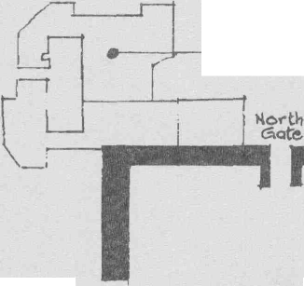

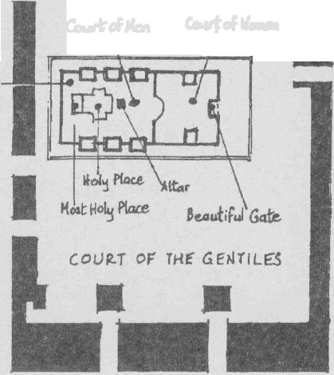
-fort of Antonio (prison)
West Gate-
Cauft d Man Court of *'<>**
Gold
of Priests
We have read about this Philip
before in chapters 6 and 8.
Q21.1 What do you know about him from these passages?
Q21.2 What were the disciples warning Paul about?
Q21.3 What did Paul think about their warnings?
A point to note
Disciples who were inspired by God gave warnings to Paul, speaking "through the Spirit" as in chapter 20:23 and 21:11. These warnings were true but Paul was more interested in serving God than saving himself.
The Jews at Jerusalem still thought the Law given to Moses was very important and some had set up false stories about Paul saying that he was teaching Jews in other countries to ignore Moses' Law. Paul did not mind if the Jewish Christians continued their interest in Moses' Law as long as they realised that it was not essential for salvation.

Herod's Temple

Christadelphian Bible Mission
Bible Study Course - Acts
Page 26

The Apostles at Jerusalem wanted Paul to show the Jews that he was not against Moses. There were four men who were under a vow, and according to the Law of Moses they had to offer a sacrifice to finish their vow. Paul agreed to pay for their sacrifices and in this way he would show some respect for the Law. It was hoped this might help the Jewish Christians at Jerusalem to accept Paul.
However, the Jews had seen him with Trophimus, who was a Gentile, and thought (wrongly) that Paul had taken this Gentile into the Temple (where only Jews were allowed). Q21.4 Then what happened?
###################################################
Acts Chapter 22
The Jews thought Paul was against their faith, so Paul in his speech says: a. He was a Jew as well (verse 3).
b. He was brought up in Jerusalem (the centre of Jewish worship), c. He was taught by Gamaliel (a most respected teacher of the Law).
d. He was zealous towards God, just as they were, even to the extent of persecuting believers of Jesus.
Notice that even when Paul was persecuting Christians he thought he was doing what God wanted (verses 3,4). He was completely sincere in what he did—and yet he did wrong. This is a warning to us. To be sincere is not enough. We must find out from the Bible what God wants us to do.
Q22.1 Who spoke to Paul and made him realise he was doing wrong?
Q22.2 What did he need to wash away?
Q22.3 How did he do this?
Q22.4 While Paul was praying in the Temple whom did he see (and who spoke to him)?
Q22.5 a What did Paul say that made the Jewish crowd really angry? b Why did this make them angry?
Note:
1. Damascus (verse 6) is still in the news. It is the capital of Syria.
2. Verses 8,14,18-21 show that Jesus Christ was alive, and was still working in the lives of the Apostles, even though he had gone to heaven.
3. In verse 3 Paul says he is a Jew. In verse 25 he claims to be a Roman. He was a Jew because his parents were Jews. He was a Roman because he was born in Tarsus, a Roman city.
4. Verse 20—Paul not only looked after the clothes of those who stoned Stephen (see chapter 7:58), but also agreed with what they were doing. So it says he was "consenting" to his death (chapter 8:1).
5. A Roman scourging or whipping was very cruel indeed and caused the death of many. They used leather strips into which pieces of metal were sewn. Paul had already been beaten by the crowd (chapter 21:32), so he told them he was a freeborn Roman citizen, and so avoided further torture. The chief captain had bought his freedom and was afraid that he would be punished for what he had already done to Paul.
Christadelphian Bible Mission <||9 Page 27 Bible Study Course - Acts

###################################################

Acts Chapter 23

CIL.ICIA
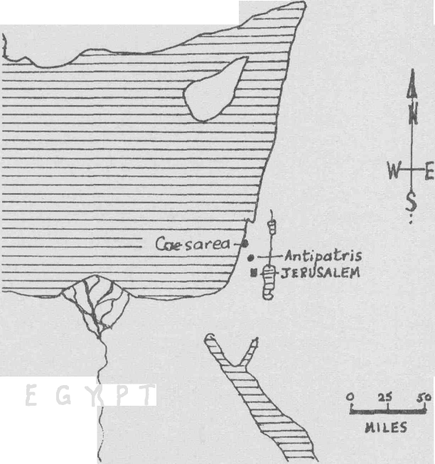
E G Y P T
Places mentioned in Acts 23

BEFORE THE SANHEDR1N (THE COUNCIL) IN JERUSALEM
Ananias the high priest was a wicked man and Paul was right to call him awhited wall. Look at Matthew 23, especially verse 27, where Jesus used similar words about the leaders of the Jews. They, and particularly the high priest, should have been teaching the people right things and showing a good example in their lives. Instead they were evil but pretended to be good. (They were hypocrites). They were so wicked that they took part in a plot to kill Paul. (Ananias the high priest is different from the Ananias in chapter 22:12).
There were Pharisees and Sadducees in the Council. Read verse 8 to see what the Sadducees and Pharisees believed.
Q23.1 What do yfiu believe?
a Is there a resurrection of the dead?
b If there is, when is it?
c Are there such things as angels?
d If so, what do they do?
e Do we have an immortal soul?
f What happens when we die?

Christadelphian Bible Mission
Page 28
Bible Study Course - Acts

Q23.2 After the uproar, what did Jesus say to Paul as he stood by him? Q23.3 When Claudias Lysias wrote to Felix (the Governor of Judea), what did he say about Paul? (Did he think he had done anything wrong)?
Some points of interest
1. When it says "The Lord stood by Paul" (verse 11), this would be an angel. Angels are often referred to in this way (see Exodus 23:20,21).
2. Caesarea (verse 23) was a city on the coast, named after the Roman Emperor, Augustus Caesar. It was the most important city in Judea, and the Governor lived there.
###################################################
Acts Chapter 24
Q24.1 Had Paul stirred up trouble?
Q24.2 In verse 14 Paul says he believes all things written in the Law and the
Prophets. What does he mean by this? Q24.3 In verse 15 he says there will be a resurrection of the dead, both of the just
and unjust. What does this mean?
VERSE 25
Paul taught Felix about righteousness. We can only be righteous when our sins are removed by baptism. We must then live a life of self-control (temperance).
Q24.4 When will God judge the world?
Q24.5 What effect did Paul's teaching have on Felix?
Felix was the Roman in charge of that area. He was married to Drusilla, who had been brought up in the Jewish religion. Felix was a wicked man and had hoped to get money from Paul, but aftertwo years Caesar removed Felix and put Festus in his place.
###################################################
Acts Chapter 25
Festus soon started to sort out Paul's case.
Q25.1 Why did the Jews want Paul to go back to Jerusalem? Q25.2 What did Festus tell them?
When accused by the Jews, Paul told them that he had done nothing against the Law, the Temple or against Caesar. Since Festus was now in the position of Governor and wanted to get on well with the Jews, he agreed that Paul could be tried at Jerusalem. Paul did not want this and so he appealed to Caesar. This was not what Festus or the Jews wanted, but it was Paul's right as a Roman citizen. Paul knew it would mean a long journey to Rome, but it would give him an opportunity to preach the Gospel (Acts 19:21; 23:11; Romans 1:15).
Note:
Agrippa was one of the Herod family and king of some of Palestine. He had been brought up in the
Christadelphian Bible Mission yl|j Page 29 Bible Study Course - Acts

Jewish religion. His sister, Bernice, had already been married twice and was now Agrippa's mistress - not a very good example! (Bernice was also Drusilla's sister.)
Q25.3 What did Festus tell King Agrippa about Paul in verses 18 and 19? Q25.4 Why did Festus want King Agrippa to hear Paul?
Notice that, although Paul was being wrongly accused he did not get angry or violent. This is how the Lord Jesus behaved when he was on trial and how we should behave if we are wrongly accused.
################################################## Please return your answers to:
Please include your reference number which is.
###################################################
Christadelphian Bible Mission fflffi Page 30 Bible Study Course - Acts

CHRISTADELPHIAN BIBLE MISSION

The Acts of the Apostles
A CORRESPONDENCE COURSE

####################################################

Acts Chapter 26

Paul said he had been a strict Pharisee. The Pharisees believed in the promises made to Abraham and others—the promise of a Messiah, and the hope of resurrection. This was what Paul had preached, so why were the Jews now accusing him? They believed these things but refused to accept that JESUS was the fulfilment of these promises, and would not believe that Jesus had risen from the dead.
Paul himself had once thought he should work against Jesus. Q26.1 What had he done?
Paul told King Agrippa how Jesus had stopped him. This is found in Acts chapter 9 but here, from verse 14 onward, he adds more of what Jesus said.
Q26.2 Copy and complete. (In some cases you will need a number of words).
Jesus said that Paul had been persecuting _____. Jesus had stopped him because he was going to make Paul a______ of what he had seen and also of what _____ .

Jesus said he would____ sent to open the eyes of the _ and turn them from idols and false worship (the power of satan).
.Paul from the people and that he was being _ to show them the light of the gospel
They could receive ______ and inheritance (a place) with the Jews who
were set apart (sanctified) by ______. Q26.3 What is meant by "do works meet for repentance" (verse 20)? Q26.4 What three things did Paul say he had been able to preach about Christ by
using the Old Testament? (see verse 23). Q26.5 What did King Agrippa and the others decide about Paul?
Q26.6 What had Paul already been told by the
""-'• •••;_-.;;_ "E Lord Jesus Christ in Acts chapter 23:11 ?

A synagogue - like those visited by Paul (see also Acts 26:11)
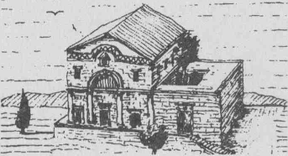
Some Points to Note
1. In verse 10 Paul calls the faithful Christians that he had persecuted "saints". All who try to follow Christ are saints (see 2 Corinthians 1:1; Ephesians 1:1 and Romans 15:25,26). The Roman Catholic Church decides whether good people who have died should be called 'saint', but the Bible uses the word 'saint' to describe all true

Christadelphian Bible Mission
Page 31
Bible Study Course - Acts

baptised believers, living or dead. It means 'set apart' or 'separate' and this is what all believers have to do; they have to separate themselves from the evil things of the world.
2. (See verse 18). Before we accept Christ we are in darkness. After accepting him we try to walk in the light of his teaching.
3. Paul said (in verse 22): "NONE OTHER things than the prophets and Moses said would happen". When he witnessed he did not add his own thoughts or feelings or anyone else's ideas to what the Scriptures had already said. We must follow his example and study the Bible for ourselves and not just listen to what others tell us about the Bible.
###################################################

Acts Chapter 27

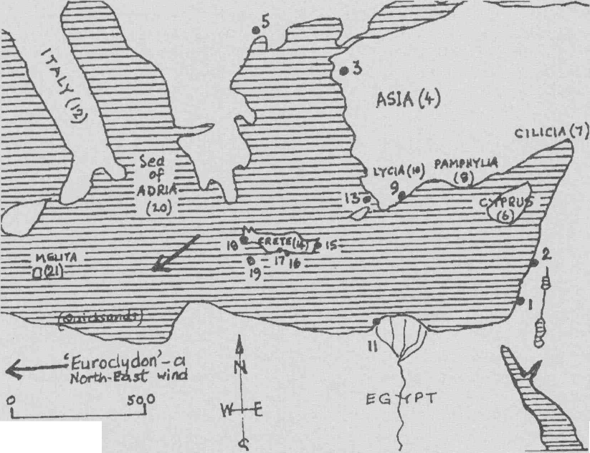
MIL.B5

Places mentioned in Acts 27
1 Caesarea 8 Pamphylia 15 Salmone
2 Sidon 9 Myra 16 The Fair Havens
3 Adramyttium 10 Lycia 17 Lasea
4 Asia 11 Alexandria 18 Phenice
5 Thessalonica 12 Italy 19 Clauda
6 Cyprus 13 Cnidus 20 Adria
7 Cilicia 14 Crete 21 Melita (ch. 28)
Having appealed to Caesar, Paul had to travel to Rome for his trial there. Paul was not alone, his brother in Christ, Aristarchus, was with him. In Colossians 4:10 (which was written from Rome), Paul described Aristarchus as a fellow prisoner. Luke might also have been travelling with him.

Christadelphian Bible Mission
Page 32
Bible Study Course - Acts

Although Paul was a prisoner, Julius, the centurion, treated him kindly, as verse 3 shows. Read through this chapter again to find ways in which God had helped Paul through this very difficult time. Q27.1 With God's help, what two things did Paul predict (tell in advance) which came true ?
Paul's belief in his God, together with his words which came true, would have impressed those he travelled with. Verse 27 shows us that this was not a one-day storm! Gradually they would have to realise that Paul's God was the true and living God.
Q27.2 What did Paul do before he ate his bread ?
Q27.3 Whose example did he follow ? (Matthew 15:36).
Verse 37 says there were 276 souls in the ship.
Q27.4 What does the word 'soul' mean ?
###################################################
Acts Chapter 28

The island to which they escaped is today known as Malta. Paul had survived the shipwreck and then he showed he could survive the poisonous snake on his hand and that he could heal people. These are two of the signs of Mark 16 :17,18 which only apply to those who have the Holy Spirit gifts. Today there are people who claim thatthey have these gifts, but they will not dare to pick up poisonous snakes, and their healing power is very limited. Paul never failed in his healing (verse 9) since this was God's power at work. God Himself still performs miracles today, and controls events in the world, and in the lives of believers; but as shown in the section on Acts chapter 8, this power is not available today for men to use.
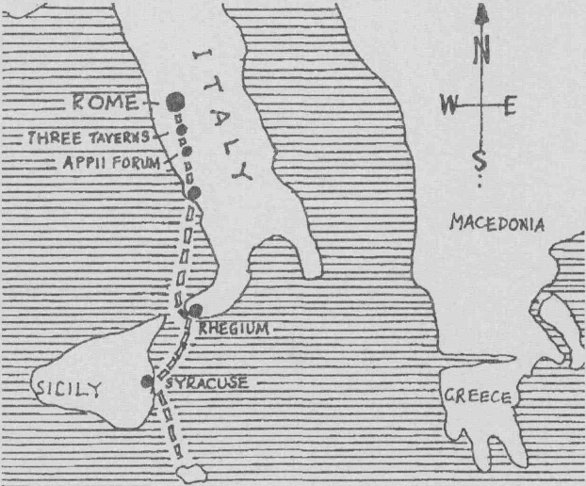
MALTA
The last part of Paul's journey to Rome (Acts 28)

1 Corinthians chapter 13 is about these gifts, and about Christian love. It says that unless a believer has this Christian love (charity) the gifts are useless. But is also says (verse 8):
"Whetherthere be prophecies (that is the Holy Spirit gift of prophecy) they shall fail" (or "be done away" in other versions).
"Whether there be tongues (gift of tongues) they shall cease." "Whetherthere be knowledge (gift of knowledge) it shall vanish away ....."
So Paul, when writing to the church at Corinth, told them there would be a time when these Spirit gifts would finish. The Spirit gifts were to help the first century believers to preach, to finish writing the Scriptures, and to help them set up the Christian church.

Christadelphian Bible Mission
Page 33
Bible Study Course - Acts

I
VERSES 13-15

Paul was allowed to stay seven days with the brethren at Puteoli, then some brethren met him at Appii forum and others at The Three Taverns. It was, and still is, important for baptised believers to have FELLOWSHIP together. This involves breaking bread, praying and singing praises together and reading'and discussing the Scriptures. In this way believers can encourage each other. So Paul was abljeto "thank God and take courage" after meeting his brethren in Christ. True fellowship is not only with brothers arid sisters of the same faith but is fellowship with God Himself and with His Son, so it is very precious (See I John 1:3).
\ }
At Rorri'e Pautwas allowed to live in his own house and to have many visitors. He was still a prisoner but he was able to continue preaching. The Jews came to him and he explained to them that he had done nothing wrong, and then taught them about the Kingdom of God and about Jesus.
Again many of the Jews would not believe. The Jews at Jerusalem had rejected Jesus and Paul, and now the Jews at Rome did not want God's salvation.
Q28.1 Which prophet had said the Jews would not hear?
Q28.2 Which people would hear?
Verses 23 and 31 say Paul preached about the Kingdom of God and about the Lord Jesus Christ. Q28.3 What do you know about:
THE KINGDOM OF GOD? (Lessons 4,9 & 11 of the postal course may help
you, together with Psalm 72).
a. Where will it be?
b. When will it start?
c. How big will it be?
d. Who will be King?
e. Where will he reign from?
f. Over whom will he reign?
g. In what ways will the Kingdom be different from the world today?
Q28.4 What do you know about:
THE LORD JESUS CHRIST? (Lessons 16-19 may help you).
a. Who was his Father?
b. Who was his mother.
c. In which country did he live?
d. Are God and Jesus equal?
e. Did Jesus exist as a person before he was born?
f. Was he christened or completely immersed in water?
g. What was he given at his baptism?
h. What does the name "Jesus" mean?
i. What does "Christ" mean?
j. Why did Jesus die? (Give at least 2 reasons).
k. Why did God raise him from the dead?
I. Where is the Lord Jesus Christ now?
m. What is the Lord Jesus doing now?
n. What will he do when he returns to the earth? (At least 3 things)
In verse 20 Paul said:"..... for the hope of Israel I am bound with this chain".
In chapter 26:6 he said: "And now I stand and am judged for the hope of the promise made of God to our fathers."
Christadelphian Bible Mission 8= B Page 34 Bible Study Course - Acts

I

The "hope of Israel" and the "hope of the promise made of God to our fathers" are the same thing. God made promises to Abraham which He repeated to isaac and Jacob. These are found in the book of Genesis. Look up each reference and write down what God promised in each. (You will find some repeated).
Q28.5 (Please copy out this table and return to your tutor for marking.)

References (all in Genesis) | What did God promise Abraham?
12: 1-3

12:7

13: 14-17

15:1-7

15: 18

17:4-8

17: 19

22: 15-18

24:7

Galatians chapter 3:16 says that there was a particular "seed" (or descendant) of Abraham that was being referred to in Genesis—the Lord Jesus Christ.
So, for example, in Genesis 22:18 where it says: "In thy seed shall all nations of the earth be blessed", it is because of the work of Jesus that all nations can be blessed. Look at Galatians 3:8: the gospel (good news) was preached to Abraham. It was that "In you (Abraham) shall all nations be blessed".
Galatians 3:14 shows that this blessing of Abraham can come on the Gentiles (all nations) through the Lord Jesus Christ. How? Galatians 3:27-29 shows that if we have been baptised into the death of Jesus we (people from all nations) can become one in Christ Jesus and therefore be counted as Abraham's descendants and share in the blessings given him. This is why baptism is so important. One of the most wonderful blessings we can receive is to have our sins forgiven. This can only be done through baptism. The Jews were given this opportunity first (see Acts 3:25,26) but most of them were not interested and rejected it. In the book of the Acts of the Apostles we have seen how this blessing was extended to all peoples. We too can share in it by having our sins removed by baptism into the death of Jesus. We can then rise to a new life of service to God, with all the blessings this brings.
(Read Romans chapter 6 and Colossians 2:12-14 and Colossians 3:1-17)
Q28.6 (a) What action must you take before you can be blessed with Abraham? (b) Having done this, in what ways will you be blessed?

Christadelphian Bible Mission
Page 35
Bible Study Course - Acts

• He will raise I • People /• Only the
*\\
-s»
be- (_^—v riqhteous
{. -^J wHI have ^ la place- in \_ God'5 jtinqaom.
' ^*^
i he returns*
>His capital j, (^ \ will be pJ Jesus died, Jcrajalewi/\ _{te} ^e
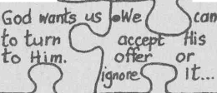

i He
f• The earth Will ie-
• There will be no more
\Will

with ^^^1 War or God's 5'ory 1 troubles .
Kino of all the World

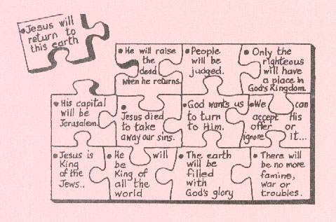上面的乱码是这张图。
###################################################
We /?ope f/7/s sfudy of the Acts of the Apostles has been interesting and has helped your understanding of the Bible.
If you have any questions about the Bible please write and ask you tutor, who will be pleased to try and answer them.
May God bless you as you continue your study of His word.
Please return your answers to:
Please include your reference number which is.

Christadelphian Bible Mission
Page 36
Bible Study Course - Acts

