SRAEL FULFILS BIBLE PROPHECY
'Ye are my witnesses ..." (Isaiah 43 v 10)
"... thou shalt become an astonishment
a proverb and a byword . . . for a sign and for a wonder ..." (Deuteronomy 28 v 37-46)
David Budden

A UNIQUE NATION
In many ways the Jewish nation is unique.
Unlike any other nation, the Jewish race can point to a definite beginning, approximately 4000 years ago.
Unlike any other nation, the Jews have been scattered worldwide — and yet have retained their national identity.
Unlike any other nation, they have been subjected to many extermination attempts — and yet have survived. The first recorded attempt was that of Haman in approximately 480 B.C. The most recent was that of Hitler. Hitler is dead.
But the Jew lives on.
"What is the secret of his (the Jew's) immortality?"
Mark Twain
' 'Yes, I am a Jew, and when the ancestors of the right honourable gentleman were brutal savages in an unknown island, mine were priests in the Temple of Solomon."
Benjamin Disraeli
* "And the letters were sent by posts into all the king's provinces, to destroy, to kill, and to cause to perish, all Jews, both young and old, little children and women, in one day, even upon the thirteenth day of the twelfth month, which is the month Adar..."
Esther 3 v 13 (c. 480 BQ
"The Final Solution" Being Jewish wa&ja capital offence in Nazi Germany.
* All Bible quotations are in italics and are from the Authorised Version of 1611 unless otherwise stated.
A UNIQUE LAND
The history of the land is unique.
In Bible times the land was marvellously fertile, "a land flowing with milk and honey.".
But after the expulsion of the Jewish people from the land in A. D. 70 the land became a barren waste of malarial swamps, stony hill-sides and parched desert. It remained in that inhospitable, neglected state until the 1930s.
Today, the land is fertile again. Fruit and flowers grown in Israel are available in our shops.
Why is this land so special?
Because the Lord God cares for it in a special way.
' 'A land which the LORD thy God careth for: the eyes of the LORD thy God are. always upon it, from the beginning of the year even unto the end of the year.''
Deuteronomy 11:12
So, a fertile land became barren. And the barren land re-gained its fertility.
But—the unique feature of it all—this is exactly what the Bible said would happen.. The Bible was right.
"And I will bring the land into desolation...as long as it lieth
desolate and ye be in your enemies' land."
Leviticus 26 v 32
"The wilderness and the solitary place shall be glad for them; and the desert shall rejoice, and blossom as the rose."
Isaiah 35 vl
A UNIQUE LAW
The Law given through Moses was unique. It set high standards of both conduct and hygiene. It identified the people with the land by regulating the sale of land and preventing families from being dispossessed. It prevented the spread of infectious diseases by a system of quarantine.
Above all, the Law called upon Israel to be "...a Holy (i.e. separate) Nation. Israel was to be an example for other nations to follow.
"Thou shalt not curse the deaf, nor put a stumbling block
be/ore the Wind..."
: Leviticus 19 v 14
' 'Just balances, just weights... shall ye have; I am the Lord your God."
Deuteronomy 24vl4
' 'Ye shall be.. .a kingdom of priests and an holy nation."
Exodus 19 v 6
Being blessed with such a law was a great privilege—but privileges bring responsibilities. If their God-given law was rejected, then the nation would suffer and would bear witness to the truth of God's Word by their suffering.
Initially, the nation gladly accepted God's law, but as time went on they rebelled. The law was spurned and regarded as an encumbrance. Instead of being a model society, the Jews followed the evil practices of the nations around them. Even human sacrifices to idols were made—by a people called to be "A Holy Nation".
"The children of Israel again did evil...and the LORD sold them into the hand o//abin...and the children of Israel cried unto the LORD..."
Judges 4 v 1-3
"Ahaz...made molten images for Baalim...moreover he... burnt his children in the jiire, after the abominations of the heathen..."
2 Chronicles 28 v1-3
So, the curses pronounced in the Law came into operation.
THE CURSES
The curses that would befall the Jewish nation if it rebelled against its God and His Law, are set out in Deuteronomy 28 v 15-68.
They fall into three sections: Section 1: Verse 15 "If thou wilt not hearken..." Section 2: Verse 45 "Because thou hearkenedst not..." Section 3: Verse 58 "If thou wilt not observe..."
Section 1: Deuteronomy 28 v 15-44. Suffering in the Land.
These verses set out the sufferings that would befall the Jewish people while they lived in their own land. There would be plagues, crop failures and oppression from enemies.
All these things happened. We can read through the books of Judges, Kings etc., to find the sorry tale repeated time and time again.
Evil — suffering — repentance — restoration — evil...
One particular curse was fulfilled at that time, and has continued to be fulfilled ever since :-
"And thou shalt become an astonishment, a proverb, and a byword, among all nations whither the LORD shall lead
thee."
Deuteronomy 28 v 37
It is as if Deuteronomy 28 v 37 was seared into the life of every Jew.
Section 2. Deuteronomy 28 v 45-57.
This section describes very vividly one specific event, an appalling siege that would befall the Jewish people.
And the sufferings would be inflicted by a nation coming ".. .as swift as the eagle flieth."
Three times the expression is used, "... and in the siege and in the straitness, wherewith thine enemies shall distress thee."
"... and he shall besiege thee in all thy gates... and thou shalt eat the fruit of thine own body, the flesh of thy sons and of thy daughters...in the siege...wherewith thine enemies shall distress thee...nothing left in the siege and in the straitness wherewith thine enemies shall distress thee..."
This terrible prophecy was fulfilled to the letter in AD70.
Jerusalem was besieged by Roman armies, whose symbol was the eagle (coincidence?), and after appalling suffering, vividly described by Josephus², an eye-witness historian, the city was devastated, the temple burnt down and the people taken into slavery.
Jews flooded the slave markets of the world, while the enormous wealth of Jerusalem was taken in triumph to Rome.
 The Roman Eagle The Standard of a Roman Legion

"The LORD shall bring a nation'against thee from far...as swift as the eagle flieth."
Deuteronomy 28 v49
"...and I will make your cities waste, and bring your sanctuaries unto desolation.
Leviticus 26 v 31
The riches of Jerusalem and manacled Jewish captives being taken by triumphant Roman soldiers, AD71.
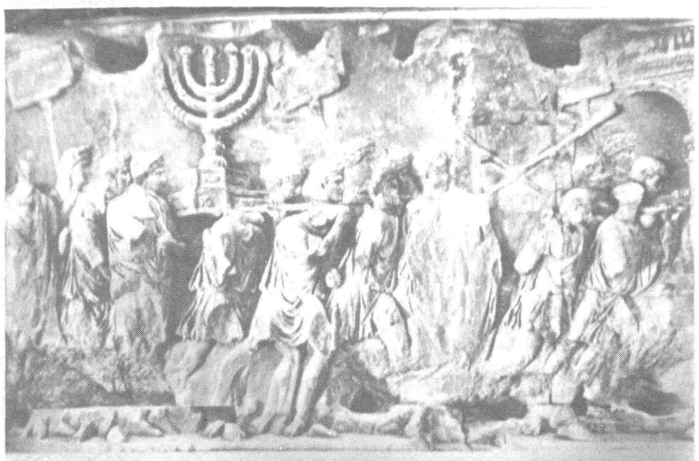
Detail from the Arch of Titus in the Roman Forum.
Other Bible prophecies, too, foretold the devastation of Jerusalem, the plundering of her wealth and the world-wide scattering of her people.
Not least on this subject are the words of Jesus himself:
"When ye shall see Jerusalem compassed with armies, then know that the desolation thereof is nigh...And they shall fall by the edge of the sword, and shall be led away captive into all nations: and Jerusalem shall be trodden down of the Gentiles..."
Luke 21 v 20-24
After the utter destruction of Jerusalem in AD70, Roman armies drew a furrow right across the site of the city as a token of its complete humiliation.
Approximately 600 years earlier, the prophet Micah had written:
"There/ore shall Zion...be plowed as a field, and Jerusalem shall become heaps..."
Micah 3 v 12
(N.B. Jerusalem was built on the slopes of Mt. Zion).
IVDAEACAPTA
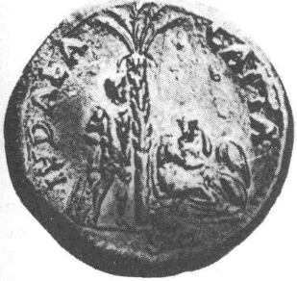
"Judaea conquered" — a Roman coin struck to commemorate the fall of Jerusalem in AD70.
A Roman warrior stands while a crouching woman in tears represents the humiliated Jewish people.

The coin was struck by the Romans for propaganda purposes. The Jews had revolted against their Roman overlords and the coin was to serve as a warning to other subject nations who may be considering rebellion.
In this way, Jerusalem's fate was widely advertised—and people were reminded every time they used this Roman money.

Section 3. Deuteronomy 28 v 58-68. Scattering and Persecution
This third section describes world-wide scattering. Constant, persistent and terrible persecution awaited them.
"...the LORD shaJI scatter thee among aJJ people, from the one end of the earth even unto the other... And among these nations shalt thou find no ease, ...thy life shall hang in doubt before thee; and thou shalt fear day and night, and shalt have none assurance of thy life: in the morning thou shalt say, 'Would God it were even', ...for the fear of thine heart wherewith thou shalt fear..."
Deuteronomy 28 v 64-67
History books abound with evidence of the fulfilment of this curse. Ever since AD70, the Jewish people have been persecuted.
The Crusaders' route cross Europe was marked with Jewish blood. For no people were the Dark Ages either as long or as dark as for the Jews. The Ukrainian Cossacks behaved in a manner foreshadowing Hitler. For many years Jews were subjected to the horrors of the Spanish inquisition, while during the late 1800s, fierce pogroms in Russia caused many Jews to flee for their lives.
The most horrific persecution of all time was waged against this special people by Hitler.
"The Wandering Jew" — a phrase that sums up the fate of Jews throughout the world and through many centuries.
"... and they shall be wanderers among the nations.
Hosea 9vl7 (written 600BC. approx. j

JEWISH PERSECUTION IN MEDIEVAL TIMES
Pictures from "Liber Chronicarum Mundi", Nuremburg 1493. By courtesy of Picture Collection, The Branch Libraries, New York Public Library.
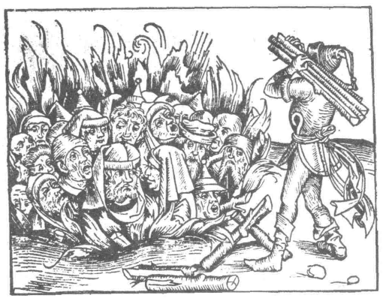
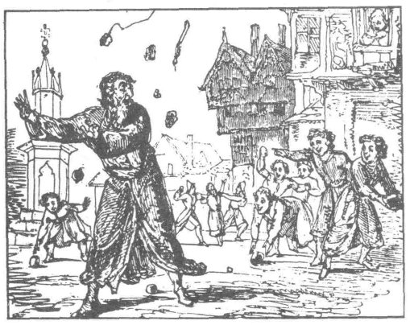
THE SURVIVAL OF THE JEWISH RACE
That the Jewish race did not become extinct centuries ago is a marvel.
Many nations — much greater in their day than the Jewish nation has ever been — have long since vanished; the Hittites, the Medes, the Babylonians, to name but three.
But the Jew lives on.
For centuries the Jewish nation had no land or self government — a " ghost'' nation, scattered among the nations of the world.
Some might claim that Jewish survival was due to a policy of deliberate separation — but this is not true. Time and time again the Jews sought to submerge their Jewishness and to integrate — but to no avail; always excluded; always alien.
Nor is Jewishness merely a matter of religion. A book published in 1978 has shown that the distribution of blood groups among Jewish people has distinctive features.³
Jewishness is a matter of race, of nationality, of origins; not merely a question of religion.
Mark Twain, contemplating the survival of the Jewish race, was moved to ask:
"What is the secret of his immortality?"
Bible prophecy, written up to 3,500 years ago, is emphatic that the Jewish race would never become extinct.
And Bible propehecy has been amply vindicated.
"...when they be in the land of their enemies, I will not cast them away, neither will I abhor them, to destroy them utterly..."
Leviticus 26 v 44
"Thus saith the LORD, which giveth the sun...moon...and stars...!/ those ordinances depart from before me...then the *.. seed of Israel shall cease from being a nation be/ore me for ever."
' Thus saith the LORD; If heaven above can be measured, and the foundations of the earth searched out beneath, I will also cast off all the seed of Israel for all that they have done, saith the LORD."
Jeremiah 31 V35-37
Note how definite this is: no "ifs", no "buts". Have the heavenly bodies ever failed? They have not!
Has the boundary of space been discovered? It has not!
Has the centre of the earth been explored? It has not!
Has the Jewish race become extinct?
"...though I moke a full end of all nations whither I have scattered thee, yet will I not make a full end of thee: but I will correct thee in measure, and will not leave thee altogether
unpunished."
Jeremiah 30 v 11
THE REGATHERING OF THE JEWS
(1) The Years of Little Interest
Theodor Herzl had founded the Zionist movement in the 1890s. Its objective was the founding of a Jewish state in the land of Palestine (the same land occupied centuries earlier by the nation of Israel).
.Generally speaking, however, Jewish reception of HerzPs idea was decidedly cool, so cool in fact, that Herzl commented bitterly, "We are not yet desperate enough; we shall have to sink still lower, we shall have to be more widely insulted, spat upon, mocked, beaten, robbed and slain, before we are ripe for the idea."⁴
Terrible words indeed — uttered in 1895. But how true they proved to be!
During the First World War, in 1917, British forces took possession of Palestine, and, thinking to win Jewish support in the war effort, promised to facilitate the establishment of a Jewish home in Palestine.
"The British government views with favour the establishment of a national home for the Jews, in Palestine.
Balfour Declaration of 1917
But this promise, far from winning widespread support, provoked division and anger against Zionism with a force that embarrassed the British government.⁵
The numbers of Jews returning to Palestine to build up their national home in those early years were pitifully small.
In 1927, 3,034 Jews immigrated into Palestine, but 5,071 emigrated. In 1928, the surplus of immigrants over emigrants amounted to just 10.
Optimists believed that anti-Semitism — persecution and discrimination against Jews — was a thing of the past.⁶
The easing of international tensions and the lessening of open hatred against the Jews nearly accomplished what all the years of persecution had failed to do.
It was a commonly held opinion among Jews that the race nearly did disappear through assimilation in the nineteenth and early twentieth centuries.⁷
"The years from 1926 — 1938 were a period of Zionist weakness.. .It looked to some people, and not only enemies, as if the Jewish national movement was about to fail and come to an end."⁸.
"As late as 1930, the Jews of Germany still wanted proudly to be Germans. Several hundred German/Jewish leaders signed an advertisement in the' Vossisch Zeitung' — a leading Berlin newspaper. This is what it said:-⁹
"We profess the Jewish religion, but reject any sort of Jewish nationalism. We regard ourselves, along with the overwhelming majority of German Jews, as members of the German, not of the Jewish people.
Note the words:-
"Overwhelming majority"
Berlin
1930
(2) The Years of Desperation
In 1933, Hitler's National Socialists came to power in Germany and immediately the dormant anti-semitism was intensified. Organised campaigns against Jews were openly encouraged.
Many Jews, rightly assessing the shape of things to come, emigrated to the only land where they were welcome — Palestine.
The trickle became a torrent. And the torrent became a flood.
But Arab hostility was provoked by the increasing numbers of Jewish immigrants and international pressure was put on the British Government, which still held the mandate of Palestine, to curb Jewish immigration.
A JEWISH REFUGEE SHIP BEING BOARDED BY BRITISH TROOPS
By courtesy of Associated Press
In 1939, the British government adopted a White Paper designed to halt further Jewish immigration into Palestine.
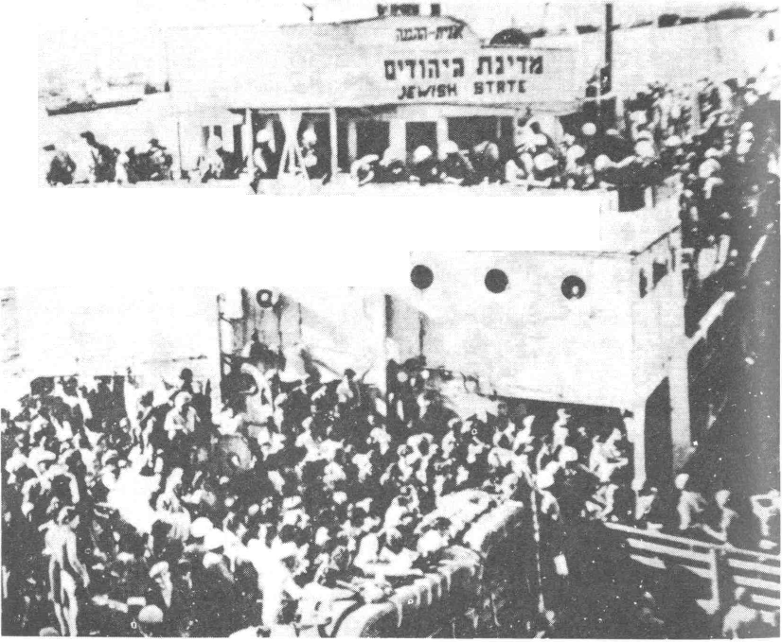
British ships patrolled the coast and many would-be immigrants were turned back.
But the Jews were in a desperate plight; ships were bought by the Jewish agency, some of them hopelessly unseaworthy, all of them crowded to the gunwales, and immigrants continued to pour into Palestine — illegally.
Bible prophecy, written about 600BC, was being fulfilled. It had been written that:
(1) The Jews would be re-gathered into the land promised to Abraham.
(2) That they would not return of their own free will—that they would be driven back by the force of circumstances.
"...it shall...be said...the LORD liveth, that brought up the children of Israel jrom...all the lands whither he had driven them, and I will bring them again into their land that I gave unto their fathers.
Behold, I will send for many fishers, saith the LORD, and they shall fish them; and after will I send for many hunters, and they shall hunt them from every mountain, and from every hill, and out of the holes of the rocks.
For mine eyes are upon all their ways: they are not hid jrom my face..."
Jeremiah 16 v 14-17
"...though I make a full end of all nations whither I have scattered thee, yet will I not make a full end ofthee: hut I will correct thee in measure, and will not leave thee altogether unpunished...
The fierce anger of the LORD shall not return, until he have done it, and until he have performed the intents of his heart; in the latter days ye shall consider it.''
Jeremiah 30 v 11-24
(3) "Through the Valley of the Shadow..."
EzekieJ's Vision of a Valley of Dry Bones
"The hand of the LORD was upon me, and carried me out in the spirit of the LORD, and set me down in the midst of the valley which was full of bones,.. .there were very many in the open valley; and lo, they were very dry.
And he said unto me, Son of man, can these bones live?
Thus saith the Lord GOD unto these bones; Behold I will cause breath to enter into you, and ye shall live: And I will lay sinews upon you, and will bring up flesh upon you, and cover you with skin, and put breath in you, and ye shall live; and ye shall know that I am the LORD.
So I prophesied as I was commanded:...there was a noise and behold a shaking, and the bones came together, bone to his bone. ...Sinews and the flesh came up upon them, and the skin covered them above:...
Then said he unto me, Prophesy unto the wind... Come_from the four winds, O breath, and breathe upon these slain, that they may live.
So I prophesied as he commanded me, and the breath came into them, and they lived, and stood up upon their feet, an exceeding great army.
Ezekiel37vl-10
The meaning of the vision was explained to the prophet:-
"... these bones are (that is, represent) the whole house of Israel: behold they say, Our bones are dried, and our hope is lost:...
Therefore prophesy and say unto them, Thus saith the Lord GOD; behold, O my people, I will open your graves, and bring you into the land of Israel..."
Ezekiel 37 v 11-14
So, that dramatic vision, given to the prophet centuries ago, depicts the people of Israel, scattered world-wide; as a nation, dead, with all hope of national life gone. Just like dry bones, scattered.
But just as the bones assembled, and just as flesh and skin covered the bones, so the Jewish nation would one day be restored.
The vision goes on to depict the restored nation acknowledging its God; the fulfilment of this still lies in the future.
The Miracle of the Rebirth of Israel
And so it came about. The modern Jewish State was born through the intense trauma of violent persecution. Hitler's Europe became ".. .the valley of the shadow..".
The rising, as it were from the dead, of Israel's "...exceeding great army" startled the world.
' 'Next year in Jerusalem'' — that yearning had been on every pious Jewish lip for 50 generations.
But before there could be ' 'next year in Jerusalem'', there had to be ".. .the brutal climax of all the world's latent anti-Semitism. Adolph Hitler was the Founding Father of the Land and of the Jews.' '¹⁰
One of the greatest ironies of history is the fact that Hitler, setting out to exterminate the Jewish race, instead became the main-spring behind the creation of modern Israel.
And so the Jews returned to the land of Palestine — the land that 4,000 years before had been promised to Abraham and his descendants:
"For all the land which thou seest, to thee will I give it, and to thy seed...arise, walk through the land.../or I will give it unto thee"
Genesis 13 v 14-17
Naturally speaking, the re-birth of the Jewish State would never have happened. The Jewish people were driven back into the Promised Land by the most terrible persecution in all history.
The Jews did not return to the land of their own free will. Neither did others want to see the Jews flocking into Palestine.
1. Hitler did not want the Jews to emigrate to Palestine; his plan was to exterminate the race.
2. The Arabs did not want the Jews to emigrate to Palestine — they were mounting a fierce campaign against Jewish immigration.
3. The British did not want the Jews to emigrate to Palestine; the 1939 White Paper was designed to halt Jewish immigration. Many thousands of would-be immigrants were prevented from entering.
4. The Jews did not want to be in Palestine; they had been the most hostile opponents of the Zionist movement. The overwhelming majority of Jews sought integration in their host countries.
Yet the Jews returned to the Land. Not because of anyone, but in spite of everyone — themselves included.
"...I will bring them again into their Jand that I gave unto their fathers.. .fishers... hunters...''
Jeremiah 16 v 15-16
So they arrived in ever increasing numbers, and the international community was faced with the problem of what to do about it.
After years of bitterness, the Palestine question was referred to the United Nations Organisation who, in May 1948, voted for the partitioning of the land between Arabs and Jews.
Following this, the State of Israel was declared. And so, the "miracle" had come about.
After nearly 2,000 years of being "The Wandering Jew", the Jew now had a home—a country in which he could live as of right; the Land occupied by his forefathers so many generations before.
Mr. David Ben-Gurion Declares the Birth of the State of Israel, May 14th 1948. By Courtesy of the Israeli Government Press Office
The re-birth had happened; but before the infant State could utter its first cry, another "miracle" was essential; and that
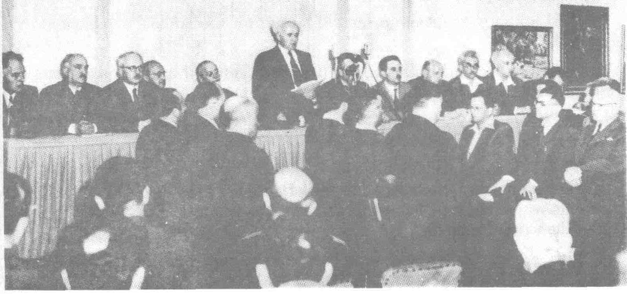
"miracle" occurred.
On its first day of life, May 14th 1948, the combined armies of the Arab forces converged on the infant in order to strangle it.
Egypt had an armoured brigade on the southern border; three regiments of Syrians were poised in the north; the Lebanese were ready to enter Galilee; the Iraqis moved a brigade to work with the Arab Legion who were well equipped with heavy artillery.

Arab aeroplanes were unopposed in the sky.
"They have said, 'Come, and let us cut them off from being a nation; that the name of Israel may be no more in remembrance."
Psahn83v4
The Jews were able to muster a mere 18,000 armed men,¹¹ ill equipped, and many of them crushed by their experiences in Europe.
Field Marshal Montgomery...knew that the Jewish case was hopeless; he commented: "The Jews have bought it."¹²
Yet, contrary to all human expectation, the Jews not only survived, they were able to secure their borders.
"No military explanation for the failure (of the Arabs) is plausible."¹'¹
"No fact in the history of the twentieth century is more staggeringly improbable than the State of Israel. "¹⁴
"They stood up upon their feet, an exceeding great army."
Ezekiel37vW
And even now, words like "The Six Day War", and "Entebbe", speak of events w^{r}hich stunned the world and about which journalists felt obliged to use the word, "miracle".
In more recent years. Jews have been able to leave the former Soviet Union and by 1987 approximately 180,000 had settled in Israel.
In 1985 no fewer than 7,000 Ethiopian Jews were air-lifted into Israel in 'Operation Moses'. These were members of a unique community thought to have descended from Jews who had lived in Ethiopia from antiquity.
"I will bring thy seed from the east, and gather thee from the west; I will say to the north, Give up; and to the south, Keep not back..."
Isaiah 43 v 5-6
THE LAND
In Old Testament times, the land of Canaan (as it was then called), was renowned for its fertility.
The spies sent into the land by Moses, brought back samples of the fruit in order to demonstrate how fertile and fruitful the land was. They brought back grapes, pomegranates and figs.
"...a land of brooks of water...that spring out of valleys and hills; a land of wheat, and barley, and vines, and fig trees, and pomegranates; a land of oil olive, and honey; a land wherein thou shaJt eat bread without scarceness.
Deuteronomy 8 v 7-9
'A land /lowing with milk and honey.
Exodus 3v8
During the years when the Jews were scattered abroad, the land fell into neglect.
As a bridge between continents and empires, the land was a constant battleground. The crusaders added their quota of destruction.
Trees were destroyed for firewood while goats nibbled grass to the roots. Winter rains washed away the soil while running streams silled up and spread out into malarial swamps.¹⁵
Desert sands edged remorselessly in.
The "land flowing with milk and honey", clothed with greenery and flowers, renowned for its fertility, became a waste of stony hillside, swamp and desert.
"...after 400 years of mis-rule,...the Turks had left behind them a waste of sand, a few overcrowded towns having no sanitary facilities and no education..."¹'¹.
(Palestine had been part of the Turkish Empire since 1517. The Turks were driven out by the British in 1917.)
In fact, the wastes of Palestine became proverbial. Wilkie Collins, in his novel "The Woman in White", published in 1859, referred to the ''.. .prospect of desolation among the ruins of Palestine...".

isalem shall in: trodden dinvn of (he gen tiles, until..,
- ukc 21 v24

But just as the; Bible foretold the re-gathering of the Jewish people into their ancient land, so it also foretold that at the same time the barren, waste land would re-gain its former fertility.
"But ye, O mountains of Israel, ye shall shoot forth your branches, and yield your fruit to my people of Israel; for they are at hand to come. For behold 1 am for you, and f will turn unto you, and ye shall be tilled and sown...and f will multiply upon you man and beast; and they shall increase and bring fruit; and f will settle you after your old estates... "
Kzekiel 36 \-8-ll
"Instead of the thorn shall come up the fir tree, and instead of the brier shall come up the myrtle tree.
Isaiah 55 v 13
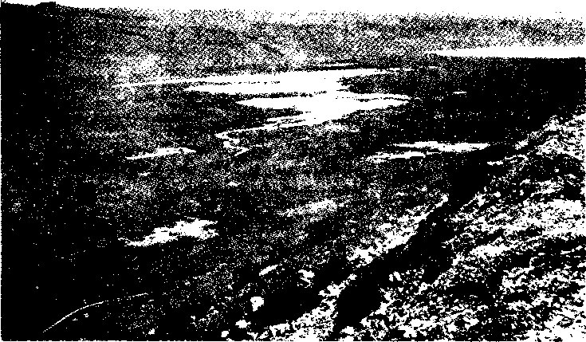

The Hule Swamps befow the start o/ //!<: Hwlamnlion I'rojwl
By courtesy of the Israel (internment Tourist otiire
The Hula Swamps after reclamation
And today, these ancient prophecies are beginning to be fulfilled. The land is being restored to its former glory and produce of Israel in the shape of oranges, avocado pears, melons, grapes, strawberries, celery, nuts and cut flowers, is available in overseas markets.
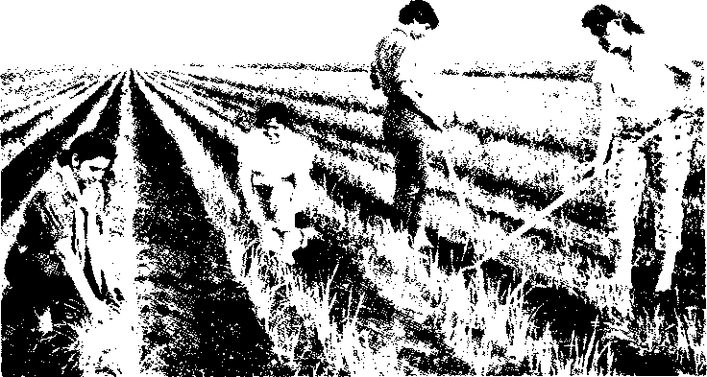
The acreage under cultivation nearly tripled between 1948 and 1977, while yields quintupled. Much of the newly cultivated land had never felt a plough for over 1,000 years.¹'
Palestine was not all a wilderness before the modern Jewish State was born — but most of it was.
"...the historic dream has proved its power to succeed...Jewish colonists.. .have made the desert bloom,.. .a score of thriving industries,.. .and a great city on a barren shore.. .electricity throughout the land. Sir Winston Churchill (Speaking in the House of Commons, 23.5.39).
"...to visit Israel at frequent intervals is to witness the slow unrolling of a vast green carpet.
The desert recedes on every side like hair on a middle aged head. "¹⁸
The history of this land, then, is highly unusual.
Why should a land that was so fertile and fruitful become a waste of stony hillside, swamp and desert?
But it did.
Why should a barren waste of stony hillside, swamp and desert become a fertile and fruitful again?
But it is doing so.
And — the unique feature of it all — this is exactly how Bible prophecy foretold that things would be.
Bible prophecy has been more than amply vindicated.
Produce of the Land of Israel Available in English Shops
Every time we buy Israeli oranges, nuts, strawberries, grapes, gladioli, etc.,, we are buying witnesses to the fulfilment of Bible prophecy.

Photograph: Karani Ram

.and the desert shall rejoice, and blossom as the rose. "
Isaiah 35 vl
The Population and the Cities
From laying the cornerstone...
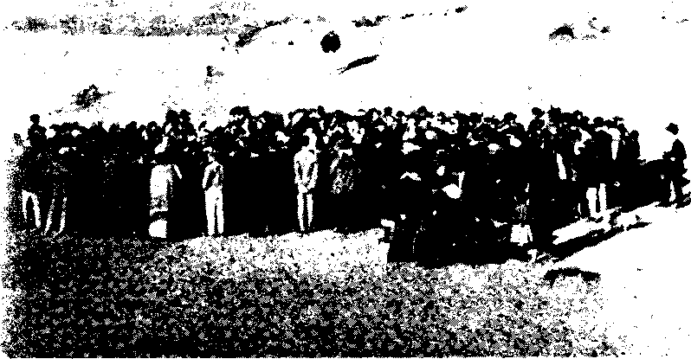
By courtesy of the Israeli Government Press Office
...to the modern city of Tel Aviv.
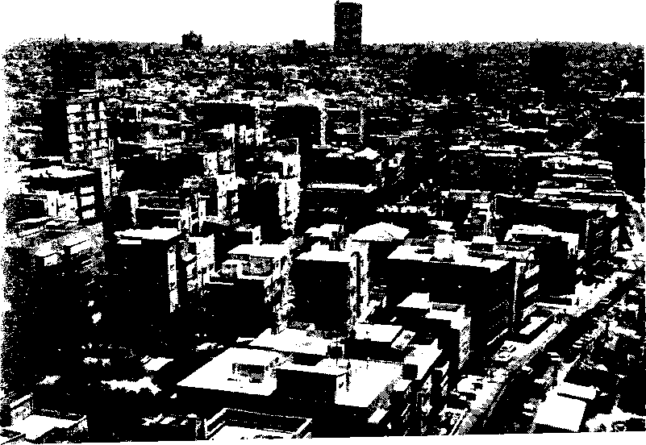

A Few of the Cities and Towns that have been Built in
Recent Years
Tel Aviv
The foundation stones were set among the sand-dunes in 1905. For a number of years Tel Aviv was the capital of the new-born State. The Port of Ashdod
A deep water harbour was opened in 1965. The port deals exclusively with cargo and is an outlet for Israeli produce going to the West. As many as 32 ships can be accommodated. Yotvata
In 1951. Yotvata was a mere border garrison. It is now an agricultural settlement (in the dry. hot Negev. be it noted) supplying Eilat with dairy produce and vegetables. Eilat
In 1949 there was just one deserted hut. Now there is a busy port with access to the Orient and to Africa.
Eilat has been developed as a popular tourist resort boasting numerous modern hotels and is recognised as one of the world's best watersport resorts. Beersheba
The name means "The well of the oath" and it was a name given by Abraham 4000 vears ago (Genesis 21 v 31). In 1948 the population was a mere 4000 but this had expanded to 130,000 by 1982, many of the residents coming from North Africa and from the former Soviet Union. There is a conservatory of music, a repertory theatre and many art and sculpture galleries. There is a medical faculty in the Ben Gurion University of the Negev. "...against all odrls. Beersheba. like; the desert, is beginning to bloom."'''. Sde Boker
A kibbutx a few miles south of Beersheba overlooking the great Wilderness of /in. Mr. David lien Gurion opterl to be¹ buried nearthis. his former kibbutz.
The kibbutzim, agricultural settlements, are a well known feature of Israel and are probably what the prophet was speaking of when he described the restoration of"...(he land of uncalled villages..." (Iv/.ekiel 38 v 11).
r f r f f k
These are just a few of the more important towns and cities to have sprung to life in modern times. There are many more, not to mention scores of villages and agricultural settlements.
"...the i.ities <:hall be inhabited... " Kzekiel .'W v 10
''...the hind brought back from the sword...the mountains of
Israel H'hff.h have ahvavs been ivuste: ...brought forth out of
f/ie nations... " Kzekiel ,'J8 vH
SUMMARISING SO FAR — AND THE CONSEQUENCES
A unique nation.
A unique history — so contrary to all normal experience and expectation.
But. the most remarkable of all these unique features is this:
THE HISTORY OF THE NATION. AND OF ITS LAND. WAS ALL SET OUT IN GREAT DETAIL IN THE PAGES OF BIBLE PROPHECY WRITTEN MANY CENTURIES BEFORE THE EVENTS.
Nor does the Bible use words like "probably" or "maybe". It is very definite; WILL.
Sometimes the Bible even uses the past tense when speaking of future events. So certain is the fulfilment that events are spoken of as if already they are a part of history.
Here lies the challenge of the Bible.
God does not ask for blind faith. Abundant evidence of the inspiration of the Bible is provided making faith in God's Word reasonable and logical, based on hard evidence.
Where else in the world is there a history book that u as written centuries in advance of the events?
Since history has proved the Bible to be inspired — God's revealed Word — we can look with confidence for the remainder of God's programme to come about.
This is FAITH — confident trust, based on good evidence.
THE ACID TEST
Under the Law of Moses, there was a test applicable to anyone claiming to be a prophet.
One failing prediction would expose the false prophet.
If, however, all "short-term" prophecies came true, then this established confidence and "long-term" prophecies could be accepted as "the Word of the LORD".
"When the word spoken...in the name of the LORD is not fulfilled and does not come true, it is not a word spoken by the LORD..."
Deuteronomy 18 v22 (NEB)
Could idols (false gods) stand up to the test?
"... let them foretell the future... let them predict things that are to be.. .Declare what will happen hereafter; then we shall know-that you are gods.
Isaiah 41 v 22-23 (NEB)
Jesus invited the same acid test to be applied to himself. He foretold the manner of his betrayal, of his death and of his resurrection, to the disciples.
' 'Now I tell you be/ore it come, that, when it is come to pass, ye may believe that I am he..."
John 13 v 19
Does Bible prophecy stand up to the test? Is the Bible the inspired Word of the Lord?
On the evidence before us, we can judge for ourselves.
BIBLE PROPHECY AND FUTURE DEVELOPMENTS
With our confidence in Bible prophecy firmly based on the experience of history, we can look at prophecies which still remain.
Firstly, though, a word of warning.
Bible prophecy has not been given to enable us to be political forecasters. Prophecy is given so that as events unfold. God's purpose can be seen working out, so reinforcing faith. There will be no room for dogmatism.
There are three important passages in the Old Testament which speak of a massive invasion of Israel. Firstly:
Zechariah chapters 12 - 14
Jerusalem is described as a "...cup o/trembling", and as "...a burdensome stone for all people that burden themselves with if..." Judali (i.e. modern Israel) is presented as "...like a torch of fire in a sheaf... " Zechariah 12 v2-3,6.
This is a vivid description of me situation that has prevailed since Jerusalem fell into Israeli hands in 1967, Israel is a tiny state vei constantly it is in the headlines of the news at the centre of world attention
Jerusalem is dear to Moslems. Christians and jews alike ami is therefore like a tinderbox constantly threatening to ignite \vorU font!,ignition.
The prophet goes on to describe an overu helming ;rn. .r-aon of the land culminating in a terrible siege ot Jerusalem with appal linu '.uttering. It seems that the Jewish State \vil! be on the brink of ut'e; rio: '\;*h her pride humbled.
When all appears to be lost, there will be a great earthquake followed by open Divine intervention.
"For I will gather all nations against Jerusalem...and the city shall be taken... Then shall (he LORD go forth... and the mount of Olives shall cleave... And the LORD shall be king overall the earth..."
Zechariah 14 v 1-9
The second passage is:
Psalm 83 This describes the plotting of Israel's enemies:
"They have said, Come, and let us cut them off from being a nation; that the name of Israel may be no more in remembrance."
Psalm 83 v 4
While Zechariah declared that "...all nations" would be gathered against Jerusalem, the Psalmist is more specific — it will be the surrounding nations — those nations filled with implacable hatred of the Jewish State whose avowed intent has always been "To drive Israel into the Sea."
One cannot be certain, but it is posible that the Psalmist and Zechariah are describing the same event.
Our third Old Testament passage is:
Ezekiel chapter 38
We have already seen that Ezekiel 36 describes the restoration of the land of Israel to its former fertility with many of the ancient towns and villages being re-built.
Chapter 37. through the highly dramatic vision of the valley of dry bones, depicts the re-gathering of the Jewish people into their ancient land with the emergence of the Jewish State.
Chapter 38 describes an invasion of the land of overwhelming proportions. Israel itself at that time is presented as:
"The land...brought back from the sivord...gathered out of many people. ...the mountains of Israel, ivhich have always been ivaste; but it is brought forth out of the nations.
Ezekiel 38v8
The invasion itself is described as coming "...like a cloud to rover the land... ". "...like a storm. "
A number of nations conrtibuting lo the confederacy an¹ named: they include "Persia. Ethiopia and Libva" (verse 3J.
Iran (the modern name of Persia)
l.'ntil a few years ago. Iran was a bastion of the west supported by billions of .American dollars. Overnight, however, the Shah was overthrown, the Americans were humiliated and the present day Moslem fundamentalist state was created. A "jihad" — a holy war — with Israel is eagerlv anticipated. Fighter planes and even whole factories for the manufacture of tanks have been acquired from the former Soviet Union. Iran has a longstanding relationship with Fibva,
. . thou shall come . . . out of the north . . . against , . .
Israel".
e/i-:kikl 38 : 15 If-.

Israel - at the hub of three continents
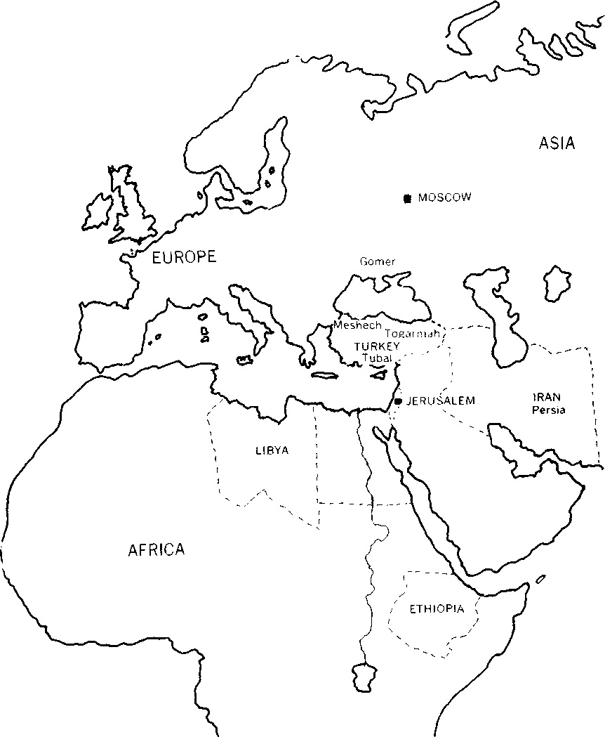

Ethiopia
Situated on the horn of Africa with a commanding position over all shipping using the Red Sea, that is, ships using the Suez Canal, Israel's port of Eilat or Jordan's port of Aqaba.
In 1977 Ethiopia signed a treaty of friendship with the Soviet Union and there is now a massive arsenal of heavy weapons of war in Ethiopia.
Libya
Ruled over by Colonel Gadafi, Libya used to be known as Moscow's most dangerous surrogate. Islamic fundamentalism is strong in Libya and there are close ties with Iran.
But there are other places mentioned in Ezekiel 38 that are not so familiar in modern ears. They are:
Meshech, Tubal, Gomer and Togarmah.
A map of ancient nations shows that Gomer was situated on the north coast of the Black Sea; the other three nations were all in modern day Turkey.
Could it be, therefore, that despite the disintegration of the Soviet Union, some elements of the old Eastern Bloc will join forces with Islamic haters of Israel to form the very alliance described in Ezekiel chapter 38? Time will tell.
Is the invasion of Israel described in Ezekiel 38 the same event as that described in Psalm 83 or Zechariah 14? It may be, but some point out that the nations involved are different and Ezekiel describes Israel at the time of the invasion as being in a position of peace and prosperity, "...at rest, dwelling without walls...". Perhaps Ezekiel is describing a second invasion which will occur at a later time.
One cannot be sure. We must wait and see.
THE FINAL OUTCOME OF THE INVASION
Zechariah, as we have seen, speaks of a great earthquake in Israel being followed by open Divine intervention in the affairs of men.
Ezekiel also speaks of open Divine intervention.
"Surely in that day there shaJJ be a great shaking in the land of Israel...and I will plead against him...mountains thrown down...an overflowing rain and great hailstones...
...and they that dwell in the cities of Israel shall go forth, and shall set on /ire and burn the weapons...and seven months shall the house of Israel be burying of them, that they may cleanse the land."
Ezekiel 38 v 18-23, 39 v 1-29
"Open divine intervention in the affairs of men." Strange words indeed in the ears of modern, sophisticated man.
But why should the idea seem incredible? Can we really believe that God created the world, that He filled it with infinite variety of living things with infinite complexity, beauty and interdependence — and then lost all interest?
The resurrection of Jesus is PROOF that God is interested.
The Bible makes it plain that one day there will be true peace between Arab and Jew, that the old Jacob-Esau hatred will be healed.
"In that day shall Israel be the third with Egypt and with Assyria, even a blessing in the midst of the land: Whom the LORD of hosts shall bless, saying, Blessed be Egypt my people, and Assyria the work of my hands, and Israel mine inheritance."
Isaiah 19 v 24-25
GOD'S DECLARED INTENT
God's avowed purpose with planet earth is declared in definite. unmistakable terms. Here are just four passages of the many.
' 'All (he earth shall be filled with iheglory of the Lord. "
Numbers 1 4 v 21
"For the earth shall be full of the knowledge of (he LORD, us the tvaters co\-er the sea.
Isaiah 11 \-^
"For thus soi'th the LORD that created (hf? heavens; Cud hi'jnseJf mat formed the earth and mode if: ...he created If not in \-ain; he formed it fo be inhabffed. . '
"P'orfhe earth shall be filled wirh (he knowledge of the sJorv of meLOHD..."
.Four passages -- one message: God created the world to he filled with life. with Divine knowledge and with Divine glory.
Thus, the prophets of doom who anticipate total destruction of nil life on earth at the hands of man. can be ignored.
Left to himself, man would, in al! probability, destroy God's creation and himself with it. Hut thu prophets ol doom have left a vita! fa( t'_"- out of the reckoning — the interests of tin? ouaw of th^ ;)!ane!. God. the Greator.
And God's declared purpose is to intervene in the affairs of men.
ANOTHER LOOK AT EZEKTEL CHAPTERS 36, 37 and 38
So far, only the beginning of the fulfilment of these chapters has taken place.
Along with the restoration of the fruitfulness of the land and the rebuilding of the towns and \illagesthereisalsotohea renewal Inspirit \\;l bin the people.
"A netv heart also ivill f give you. and u netv spin! n ill f put within you: and f nil! fake mtnv 'he sfnny henM ouf of ynur flesh... And ye shall dwell in (lie fund (hnf I gave fu your fathers; and ye shall be my people, un. I f n i II b(? your God.
K/ckie,'. 'Mi \2-4-28
"One king sball be king !o mem all. ..so shall fhev be my people, and I a ih" befheirGud. '
"\Vhen J have bronghl them ugnin fny gathered them nut offheir enemies' irmds
lamfheLOHDfheirGod...'
Prophecy is emphatic on there being a change :<i li^r; : vong the |ewish people: a restoration ol spirit
At present there is little sign of any such change \lodi-i "• Isnii;! is as ungodk and as materialistic a nation as any other on thr iacc "1 the *\iMh.
This situation is. though, to be expected.
Prophecy has declared that the jews wnuld return to the land neither in faith nor Godly zeal, but rather in spite of themselves — they would be driven back by the force of circumstances.
And so it has been.
This renewal of spirit is yet to occur; it still lies within the future.
Then what circumstances might bring about such a complete change of heart?
The answer has already been alluded to and is provided by the prophet Zechariah:
"They shall look upon me whom they have pierced, and they shall mourn... and shall be in bitterness.''
Zechariah 12 v9-10
And again, from the same prophet:
"And one shall say unto him, What are those wounds in thine hands? Then he shall answer, Those with which I was wounded in the house of my friends.''
Zechariah 13 v 6
THE SECOND COMING OF JESUS
Jesus of Nazareth lived, died, rose again from the dead and ascended to heaven approximately 2.000 years ago.
But he promised to "come again". He was not to remain in heaven for ever. but UNTIL the time in God's purpose was ripe.
There are scores of references in the New Testament to the Second doming of Jesus; below, just four examples are given:
"And then shall they see the Son of man coming m a cloud with power and great glory.
J.uke21v27
"This same Jesus...shall so come in like manner us ye have seen him go into heaven.
.Ac/si vll
"Jesus Christ...whom the heaven must receive until the times of restitution of all things, which God hath sunken by the mouth of all his holy prophets... "
Acts;* v 19-21
"There shall come in the last days scoffers... soy ing 'where is the promise ofhiscoming?'... The Lord is nof slack concerning his promise..."
2 Peter 3 v 3-9
These are just four out of the numerous references in the New Testament to the Second Coming of Jesus.
Nor will Jesus come as a humble preacher, but rather with power and authority.
Putting Old Testament and New Testament references together, it seems that Israel is to be humbled. When all hope appears to be lost, open Divine intervention will be seen and Jesus will be revealed.
In a contrite spirit, the Jewish people will recognise and welcome their Redeemer.
UNTIL...
There are several passages of scripture in which this important word appears. The word suggests that a certain state of affairs will prevail for a time, but that eventually there will be a change.
"Jerusalem shall be trodden down of the Gentiles UNTIL the times of the Gentiles be fulfilled.''
Luke 21 v 24
Jesus himself foretold the destruction of Jerusalem and the scattering of the Jewish people. However, his words make it plain that eventually Jerusalem would be restored to the Jews.
"Jesus Christ...whom the heavens must receive UNTIL the times of restitution..."
Acts 3 v 20-21
Peter, preaching on the day of Pentecost, taught that Jesus had ascended to heaven, but that he would come again. The second coming of Jesus would be associated with times of restitution and of blessings.
The last Jewish King to rule in Jerusalem was Zedekiah who lived approximately 500 years before Christ. He was taken captive to Babylon — with the words of Ezekiel the prophet ringing in his ears:-
"Thou profane, wicked prince of Israel... Thus saith the Lord GOD; ...take off the crown... I will overturn, overturn, overturn it and it shall be no more, UNTILhe come whose right it is...''
Ezekiel 21 v25-27
The implication is that one day a Jewish King would rule over the Jewish nation. That king is described as "He whose right it is. "
The Jewish nation was overturned by the Babylonians in 587BC: again it was overturned by the Romans in AD70. Will there be a third overturning in the future followed by a miraculous deliverance?
We can be sure that there will be no king ruling over the Jews until he comes "whose right it is".
THE KING OF THE JEWS
Remember the narrative of the birth of Jesus: Wise men travelled to Jerusalem from the east on a definite quest:
"Where is he that is born King of the Jews?"
Matthew 2 v2
Mary, his mother, had already received a tremendous promise concerning her child:
"He shall be great...and the Lord God shall give unto him the throne of his father (ancestor) David.
Luke Iv 32
But Jesus was rejected by most of the Jewish people and he stood on trial for his life before Pontius Pilate.
"Art thou the King of the Jews?" "Thousayestit"(i.e.. "Yes, lam.")
Luke 23v3
Shortly afterwards he was publicly executed — with the charge against him pinned over his head in Latin, Greek and Hebrew.
JESUS OF NAZARETH
THE KING OF
THE JEWS
John 19 v 19
So Jesus died; his enemies jubilant and his friends shattered, disillusioned men. But with his resurrection their hopes revived and they asked him:
' 'Wilt thou at this time restore again the Kingdom to Israel?''
Acts: v6
The reply that Jesus gave is important:
"It is not for you to know the times or the seasons which the Father hath put in his own power.
Actsl v7
In other words. "Yes, one day I will restore the Kingdom of Israel, but it is not your place to know exactly when."
The ascension of Jesus was accompanied by a promise of his return:
"Thissame/esus.'.. shall so come... "
Actsl vll
JERUSALEM
King David, who lived approximately 1,000 years before Christ, ruled in Jerusalem. To him. God promised a descendant who would reign on his throne over a divided kingdom.
"And when thy days be fulfilled...! will set up thy seed after fhee... and I will establish the throne of his kingdom forever,''
2 Samuel 7 v 12-13
A thousand years later, Mary was told that she would bear the Messiah. Mary was in direct descent from David.
"...call his name Jesus... and the Lord God shall give unto him the throne of his father David. ..and of his kingdom there shall be no end..."
Luke I v 31-33
Jesus himself taught:
' 'Jerusalem... is the city of the great King.''
Matthew 5 v35
But from that day to this, there has never been a King of the Jews ruling in Jerusalem.
Today. Jerusalem threatens to become once again the focal point of tremendous conflict which might easily draw in the world's super powers. We have already seen that Bible prophecy, written well over 2.000 years ago. anticipated this situation.
"Behold, I will make Jerusalem a cup of trembling unto all people round about...in that day will I make Jerusalem a burdensome stone for all people: all that burden themselves with if shall be cut in pieces... "
Zechariah 12 v2-3
Yet the same prophet goes on to say:
"Jerusalem shall be inhabited again in her own place, even in Jerusalem."
Zechariah 12v6
Jesus himself foretold the destruction of Jerusalem amid scenes of terrible suffering. As he carried his cross to Calvary, he said to the women lamenting his fate:
"Daughters of Jerusalem, weep not for me, but weep for yourselves and for your children. For behold the days are coming in which they shall say, Blessed are the barren."
Luke 23 v 27-31
"As some spake of the temple... he said, ...the days will come in the which there shall not be left one stone upon another that shall not be thrown down...They shall fall by the sword and shall be led away captive into all nations: and Jerusalem shall be trodden down of the gentiles, until... "
Luke 21 v24
These words were fulfilled less than forty years after the crucifixion of Jesus. An eye-witness historian vividly recorded the appalling suffering that accompanied the destruction of Jerusalem by the Romans in AD70.
Though Jerusalem is still a "burdensome stone" in the world, this situation is not to last.
After the second coming of Jesus, with power and authority to save the world from self destruction, Jerusalem will become a city of peace. ("Salem" = Peace).
' 'Behold, I create Jerusalem a rejoicing, and her people a joy.''
Isaiah 65 v 18
The prayers of those who believe God's promises will include a prayer for Jerusalem.
"Ye that make mention of the LORD, keep not silence, and give him no rest, till he establish, and till he make Jerusalem a praise in the earth. "
Isaiah 62 v 6-7
"Pray for the peace of Jerusalem: they shall prosper that love thee."
Psalm 122 v 6
At his entry into Jerusalem on "Palm Sunday", Jesus was, in effect, claiming that the Old Testament prophecies applied to himself. Centuries earlier, Zechariah had written:
"Rejoice greatly, O daughter of Jerusalem: behold thy King cometh unfofhee: ...riding upon an ass..."
Zechariah 9 v9
"AJJ this was done, that it might be fulfilled, which was spoken by the prophet, saying...Behold thy King corneth unto fhee...
Matthew 21 v4-5 By his action, Jesus was saying, "I am your King."
The Psalmist, writing 1000BC approximately, had written:
'' The joy of the whole earth is Mount Zion... the city of the great King."
Psalm 48 v2
We have already seen that Jesus quoted those words himself, in "The Sermon on the Mount".
When Jesus rules in Jerusalem then righteus laws will go forth with power and authority. Then, and then only, Jerusalem will become a centre of world peace, a joy in the earth.
Then the promises made to David and to Mary will be fulfilled.
THE KINGDOM OVER WHICH JESUS WILL RULE
Already, beginnings have been seen in the fulfilment of prophecy concerning the fertility of the land.
But much, much greater things are in store.
1. Though Jerusalem and the "Promised Land" will be the focal point of the Kingdom, nevertheless, the influence.power and authority of Jesus will extend world wide.
"He shall have dominion... unto the ends of the earth.
Psalm72v8
2. Nations will be taught a righteous way of life. There will be no military academies: weapons of war will be put to constructive uses.
"People shall... say, let us go up to the mountain of the LORD and he will teach us of his ways... they shall beat their swords into plowshares...nation shall not lift up sword against nation, neither shall they learn war any more. "
fsaiah 2 v3-5
3. There will be justice accompanied by the power and authority to rule effectively.
"...the spirit of wisdom and understanding., he shall not judge after the sight of his eyes...but with righteousness shall he judge the poor.''
Isaiah 11 vl-4
4. There will be abundant food for all. Men will work with pride and dignity.
"...corn... upon the top of the mountains; the fruit thereof shall shake like Lebanon: and they of the city shall flourish. "
Psalm 72 v 6
"...even⁷ man under his vine and under his fig tree... "
Micah 4 v4
5. Even the animal world will be influenced.
"They shall not hurt nor destroy.
Isaiah 11 v 9
6. The language barrier will be removed.
"Then will I turn to the people a pure language that they may all call upon the name of the LORD... "
Zephaniah 3 v9
Gradually the earth will be cleansed. Evil men will be checked and strife will cease.
The only man who has been able to master human nature, will be entrusted with absolute power. Jesus of Nazareth, the man born to be King, who died as a King and who promised to come again to rule, will rule the earth in righteousness on behalf of his Father.
' 'He shall.. .put down all rule and all authority and power. For he must reign till he hath put all enemies under his feet."
1 Corinthians 15 v 23-28
"The kingdoms of this world are become the kingdoms of our Lord and of his Christ; and he shall reign for ever.
Revelation Ilvl5
******
It is not easy to believe this.
But it is even harder not to believe it.
The whole of nature, so full of beauty, design, infinite complexity, diversity and inter-dependence, shouts of a creator's hand. Could "chance" produce one drop of life-giving blood?
The life, death and resurrection of Jesus, is proof of God's interest.
God the creator, created the world with a purpose; that purpose is clearly set out in the pages of the Bible.
God wants individuals who, of their own free will, have chosen to respond to Him. They honour Him by believing His promises. The present world is so evil because most people ignore God's Word and live self-centred lives instead.
God has given abundant evidence that the Bible is His Book; some of that evidence has been presented in these pages.
God does not ask for blind credulity. He gives reason to believe — and then looks for trust on our part.
It is impossible to please God and not believe His promises; to disbelieve is an insult to God.
' 'Without faith it is impossible to please him...''
Hebrews 11 v 6
Finally, the Lord's prayer is pondered by millions the world over. The prayer includes a plea for God's Kingdom — the Kingdom briefly depicted in these pages:
"Thy Kingdom come. Thy will be done in earth.
Matthew 6 v 10 "Even so, come Lord Jesus. "
Hcvelation22v20
BIBLIOGRAPHY
1. Yehudi Menuhin. "Unfinished Journey"
2. Josephus. "The Wars of the Jews"
3. Mourant et al. "The Genetics of the Jews"
4. Herbert Agar (I960). "The Saving Remnant" p.78
5. ibid p.57
6. Sykes C. (1965). "Cross Roads to Israel" p.Ill
7. ibid p.442
8. ibid p. 109
9. Herbert Agar (1960). "The Saving Remnant" p.77
10. James Cameron (1076). "The Making of Israel".
11. ibid.
12. Herbert Agar (1960). "The Saving Remnant" p.217
13. ibid p.219
14. Sykes C. (1965). "Cross Roads to Israel" inside cover.
15. Nora B. Kubie. "Israel" (1968) p.17
16. Herbert Agar (1960). "The Saving Remnant" p.62
17. ibid p.62
18. Bermant (1977). "The Jews" p.220
19. David Stone. British Medical Journal (1983).286.1646
Christadelphian A.I..S.. FREEPOST, Kings Norton. Birmingham
For FREE BOOKS send to:
Please send me mi! FREE COPIES of the book "The Bible. The Lord Jesus and You" and a Bible Reading Planner.

